**SAVEETHA INSTITUTE OF MEDICAL AND TECHNICAL SCIENCES**

**SAVEETHA SCHOOL OF ENGINEERING**

**LABORATORY RECORD**

**ITA0448**

**Statistics with R Programming for Vectorized Expressions**

**LIST OF LAB EXPERIMENTS**

1. **BASIC OPERATIONS IN R**
2. **DATA STRUCTURES IN R**
3. **WORKING WITH LOOPING & FUNCTION IN R**
4. **IMPLEMENTATION OF VECTOR RECYCLING, APPLY FAMILY & RECURSION**
5. **CREATE AND MANIPULATING DATA FRAMES**
6. **RESHAPE FUNCTION IN R**
7. **MELTING AND CASTING IN R**
8. **FILE MANIPULATION IN R**
9. **UNIVARIATE ANALYSIS IN R - MEASURES OF CENTRAL TENDENCY**
10. **UNIVARIATE ANALYSIS IN R - MEASURES OF DISPERSION**
11. **BIVARIATE ANALYSIS IN R -CROSSTAB, COVARIANCE, CORRELATION**
12. **VISUALIZATION IN R**
13. **LINEAR REGRESSION ANALYSIS IN R**
14. **MULTIPLE REGRESSION ANALYSIS IN R**
15. **LOGISTIC REGRESSION ANALYSIS IN R**
16. **POISSON REGRESSION ANALYSIS IN R**

**A. BASIC OPERATIONS IN R**

**1**.**Write the Commands To Perform Basic Arithmetic In R.**

**Aim:**

**Procedure:**

**Program:**

1. Addition (+)

2 + 3

# Output: [1] 5

# Adding a sequence of numbers

1:5 + 3

# Output: [1] 4 5 6 7 8

2. Subtraction (-)

# Subtracting two numbers

10 - 3

# Output: [1] 7

# Subtracting a sequence of numbers

1:5 - 3

# Output: [1] -2 -1 0 1 2

3. Multiplication (*)

# Multiplying two numbers

2 * 3

# Output: [1] 6

# Multiplying a sequence of numbers

1:5 * 3

# Output: [1] 3 6 9 12 15

4. Division (/)

# Dividing two numbers

10 / 5

# Output: [1] 2

# Dividing a sequence of numbers

1:5 / 2

# Output: [1] 0.5 1.0 1.5 2.0 2.5

5. Exponentiation (^)

# Raising a number to a power

2^3

# Output: [1] 8

# Raising a sequence of numbers to a power

1:5^2

# Output: [1] 1 4 9 16 25

6. Modulus (%%)

# Finding the remainder of a division

10 %% 3

# Output: [1] 1

# Finding the remainder of a sequence of divisions

1:5 %% 2

# Output: [1] 1 0 1 0 1

**```**

**Result:**

**2. Declare Variables In R And Also Write The Commands For Retrieving The Value Of The Stored Variables In R Console.**

**Aim:**

**Procedure:**

**Program:**

x <- 5

y <- "Hello, World!"

z <- TRUE

> x

**Output:**

[1] 5

> y

[1] "Hello, World!"

> z

[1] TRUE

**Result:**

**3. Write R script to calculate the area of Rectangle.**

**Aim:**

**Procedure:**

**Program:**

length <- 5

width <- 10

area <- length * width

print(area)

**Output:**

[1] 50

**Result:**

**4.Enumerate The Process To Check Whether A Given Input Is Numeric , Integer , Double, Complex in R.**

**Aim:**

**Procedure:**

**Program:**

x <- 5

is.numeric(x)

# Output: TRUE

y <- 3L

is.integer(y)

# Output: TRUE

z <- 3.14

is.double(z)

# Output: TRUE

w <- 2 + 3i

is.complex(w)

# Output: TRUE

**Result:**

**5. Illustration of Vector Arithmetic.**

**Aim:**

**Procedure:**

**Program:**

# Define two vectors

x <- c(1, 2, 3)

y <- c(4, 5, 6)

# Add the vectors

z1 <- x + y

# Output: [1] 5 7 9

# Subtract the vectors

z2 <- x - y

# Output: [1] -3 -3 -3

# Multiply the vectors element-wise

z3 <- x * y

# Output: [1] 4 10 18

# Divide the vectors element-wise

z4 <- x / y

# Output: [1] 0.25 0.4 0.5

# Raise the vectors to a power element-wise

z5 <- x ^ 2

# Output: [1] 1 4 9

# Take the square root of the vectors element-wise

z6 <- sqrt(x)

# Output: [1] 1.000000 1.414214 1.732051

**Result:**

**6. Write an R Program to Take Input From User.**

**Input name as “Jack” and age as 17.**

**The program should display the output as**

**“Hai , Jack next year you will be 18 years old”**

**Aim:**

**Procedure:**

**Program:**

name <- readline(prompt = "Enter your name: ")

age <- readline(prompt = "Enter your age: ")

age <- as.numeric(age)

next_year_age <- age + 1

**Output:**

message("Hai, ", name, ", next year you will be ", next_year_age, " years old.")

Enter your name: Jack

Enter your age: 17

Hai, Jack, next year you will be 18 years old.

**Result:**

**B.DATA STRUCTURES IN R**

**1) Perform Addition, Subtraction, Multiplication and Transpose of a Matrix in R**

**Aim:**

**Procedure:**

**Program:**

name <- readline(prompt = "Enter your name: ")

age <- readline(prompt = "Enter your age: ")

age <- as.numeric(age)

next_year_age <- age + 1

**Output:**

message("Hai, ", name, ", next year you will be ", next_year_age, " years old.")

Enter your name: Jack

Enter your age: 17

Hai, Jack, next year you will be 18 years old.

**Result:**

**2) Find Transpose of matrix in R and deconstruct a matrix.**

**Aim:**

**Procedure:**

**Program:**

mat <- matrix(c(1, 2, 3, 4, 5, 6), nrow = 2, ncol = 3)

element1 <- mat[1,1]

element2 <- mat[2,3]

element3 <- mat[2,]

element4 <- mat[,2]

print(element1)

print(element2)

print(element3)

print(element4)

**Output:**

[1] 1

[1] 6

[1] 2 4 6

[1] 2 4

**Result:**

**3) Perform the operation of combining matrices in R using cbind() and rbind() functions.**

**cbind()**

**Aim:**

**Procedure:**

**Program: cbind()**

mat1 <- matrix(c(1, 2, 3, 4, 5, 6), nrow = 2, ncol = 3)

mat2 <- matrix(c(7, 8, 9, 10, 11, 12), nrow = 2, ncol = 3)

combined_mat <- cbind(mat1, mat2)

print(combined_mat)

**Output:**

[,1] [,2] [,3] [,4] [,5] [,6]

[1,] 1 3 5 7 9 11

[2,] 2 4 6 8 10 12

**Program: rbind()**

mat1 <- matrix(c(1, 2, 3, 4, 5, 6), nrow = 2, ncol = 3)

mat2 <- matrix(c(7, 8, 9, 10, 11, 12), nrow = 2, ncol = 3)

combined_mat <- rbind(mat1, mat2)

print(combined_mat)

**Output:**

[,1] [,2] [,3]

[1,] 1 3 5

[2,] 2 4 6

[3,] 7 9 11

[4,] 8 10 12

**Result:**

**4) Perform array manipulation in R .**

**Aim:**

**Procedure:**

**Program:**

arr <- array(1:12, dim = c(2, 3, 2))

# Output: , , 1

# [,1] [,2] [,3]

# [1,] 1 3 5

# [2,] 2 4 6

# , , 2

# [,1] [,2] [,3]

# [1,] 7 9 11

# [2,] 8 10 12

# Reshape the array to have dimensions 3x2x2

arr_reshaped <- aperm(arr, perm = c(2, 1, 3))

# Output: , , 1

# [,1] [,2]

# [1,] 1 7

# [2,] 3 9

# [3,] 5 11

# , , 2

# [,1] [,2]

# [1,] 2 8

# [2,] 4 10

# [3,] 6 12

# Select the first row of the first matrix in the array

row_1 <- arr[1, , 1]

# Output: 1 3 5

# Select the second column of the second matrix in the array

col_2 <- arr[, 2, 2]

# Output: 9 10

**Result:**

**5) Perform calculations across array elements in an array using the apply() function.**

**Aim:**

**Procedure:**

**Program:**

arr <- array(1:9, dim = c(3, 3))

row_sums <- apply(arr, 1, sum)

# Output: 6 15 24

col_prods <- apply(arr, 2, prod)

# Output: 1 8 27

**Result:**

**6) Create a data frame and print the structure of the data frame in R.**

**Aim:**

**Procedure:**

**Program:**

df <- data.frame(

name = c("Alice", "Bob", "Charlie"),

age = c(25, 30, 35),

employed = c(TRUE, FALSE, TRUE)

)

str(df)

**Output:**

'data.frame': 3 obs. of 3 variables:

$ name : Factor w/ 3 levels "Alice","Bob",..: 1 2 3

$ age : num 25 30 35

$ employed: logi TRUE FALSE TRUE

**Result:**

**7) Demonstrate the creation of S3 class and S4 class in R.**

**Aim:**

**Procedure: S3 class and S4 class**

**Program: S3 class**

Person <- function(name, age) {

person <- list(name = name, age = age)

class(person) <- "Person"

person

}

p <- Person("Alice", 25)

class(p)

# Output: "Person"

p$name

# Output: "Alice"

p$age

# Output: 25

**Program: S4 class**

setClass("Person", slots = c(name = "character", age = "numeric"))

p <- new("Person", name = "Alice", age = 25)

class(p)

# Output: "Person"

p@name

# Output: "Alice"

p@age

# Output: 25

**Result:**

**8) Demonstrate the creation of Reference class in R by defining a class called students with fields – Name, Age , GPA. Also illustrate how the fields of the object can be accessed using the $ operator. Modify the Name field by reassigning the name to Paul.**

**Aim:**

**Procedure:**

**Program:**

setRefClass("students", fields = list(

Name = "character",

Age = "numeric",

GPA = "numeric"

))

s <- new("students", Name = "Alice", Age = 20, GPA = 3.8)

**Output:**

s$Name

# Output: "Alice"

s$Age

# Output: 20

s$GPA

# Output: 3.8

s$Name <- "Paul"

s$Name

# Output: "Paul"

**Result:**

**C. WORKING WITH LOOPING AND FUNCTIONS IN R**

**1.Write a program to check whether an integer (entered by the user) is a prime number or not using control statements**.

**AIM:**

**PROCEDURE:**

**CODE:**

num <- as.integer(readline("Enter a number: "))

# function to check whether a number is prime or not

is_prime <- function(n) {

# 1 is not a prime number

if (n == 1) {

return(FALSE)

}

# check for factors other than 1 and n

for (i in 2:(n-1)) {

if (n %% i == 0) {

return(FALSE)

}

}

# if no factors other than 1 and n, it is a prime number

return(TRUE)

}

# check if the number is prime or not

if (is_prime(num)) {

cat(num, "is a prime number.")

} else {

cat(num, "is not a prime number.")

}

**OUTPUT:**  
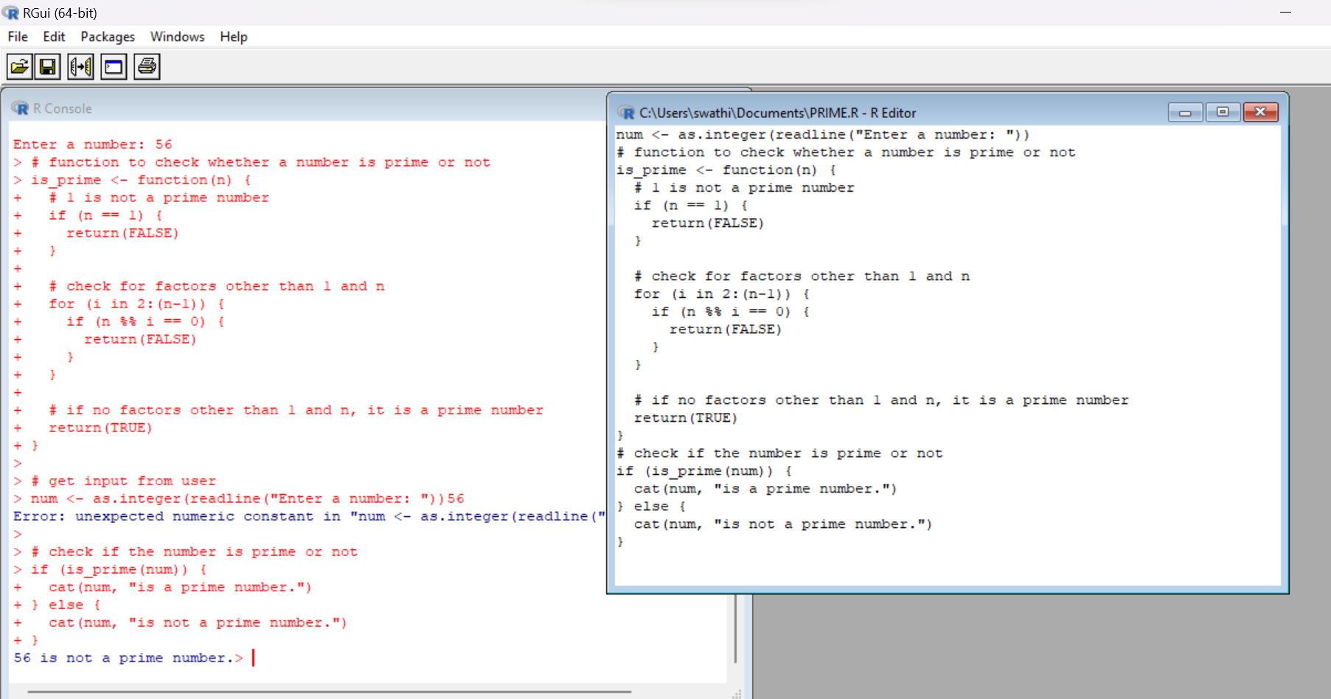

**RESULT:**

**2.Write a program to check whether a number entered by the user is positive number or a negative number or zero.**

**AIM:**

**PROCEDURE:**

**CODE:**

# get input from user

num <- as.numeric(readline("Enter a number: "))

# check the number

if (num > 0) {

cat(num, "is a positive number.")

} else if (num < 0) {

cat(num, "is a negative number.")

} else {

cat("The number is zero.")

}

**OUTPUT:**

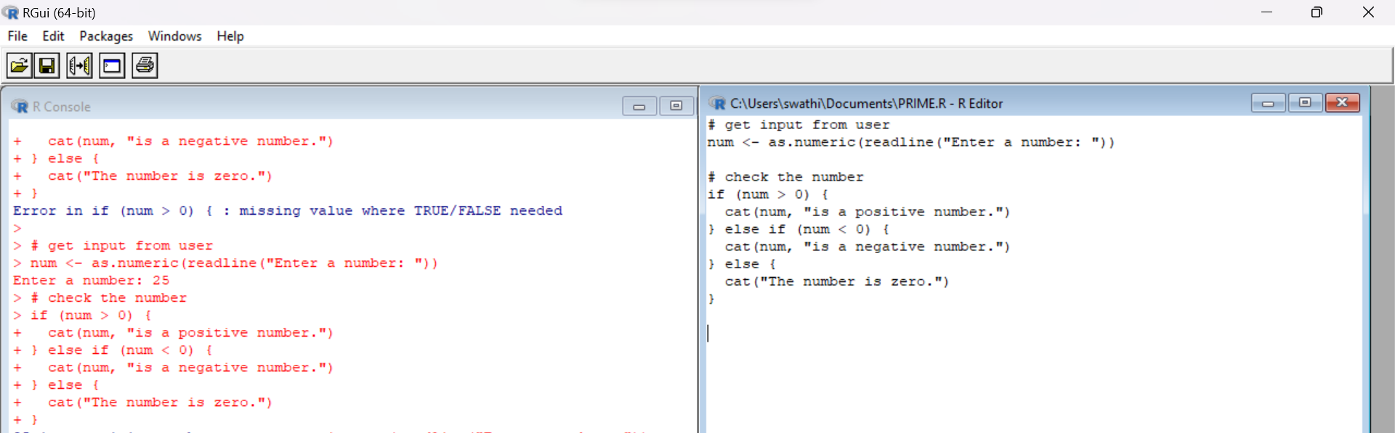

**RESULT:**

**3.Write a program to check whether a number is an Armstrong number or not using a while loop.**

**AIM:**

**PROCEDURE:**

**CODE:**

num = as.integer(readline(prompt="Enter a number: "))

sum = 0

temp = num

while(temp > 0) {

digit = temp %% 10

sumsum = sum + (digit ^ 3)

temp = floor(temp / 10)

}

if(num =sum)

{

print(paste(num, "is an Armstrong number"))

} else

{

print(paste(num, "is not an Armstrong number"))

}

**OUTPUT:**

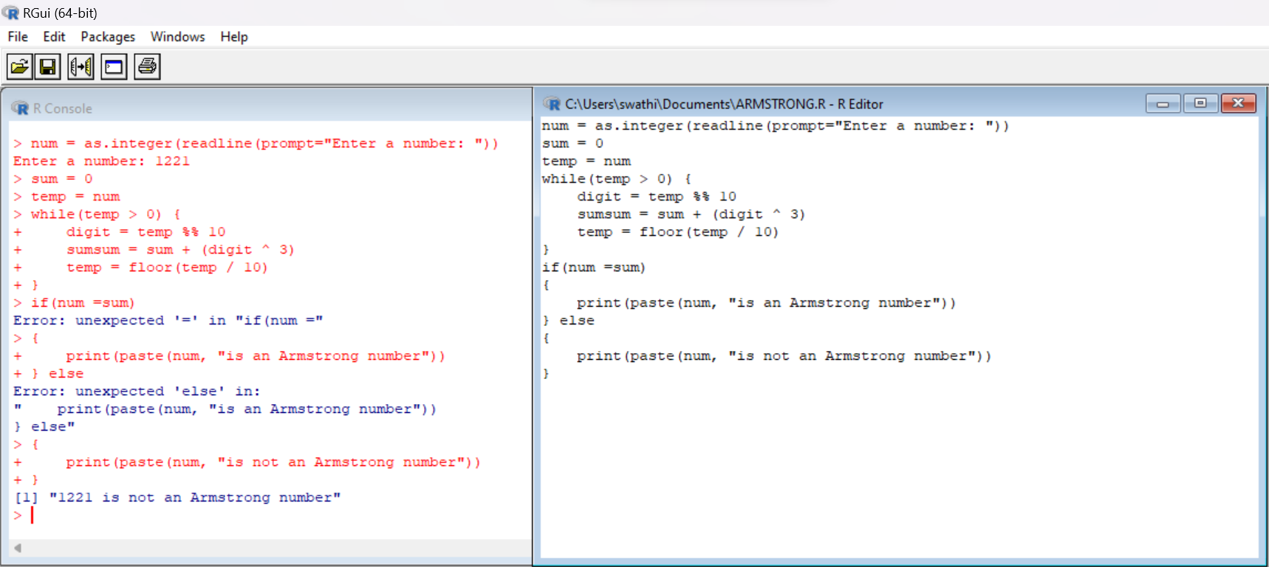

**RESULT:**

**4.Write a program to demonstrate Repeat Loop in R**

**AIM:**

**PROCEDURE:**

**CODE:**

x = 1

# Repeat loop

repeat {

print(x)

# Break statement to terminate if x > 4

if (x > 4) {

break

}

# Increment x by 1

x = x + 1

}

**OUTPUT:**

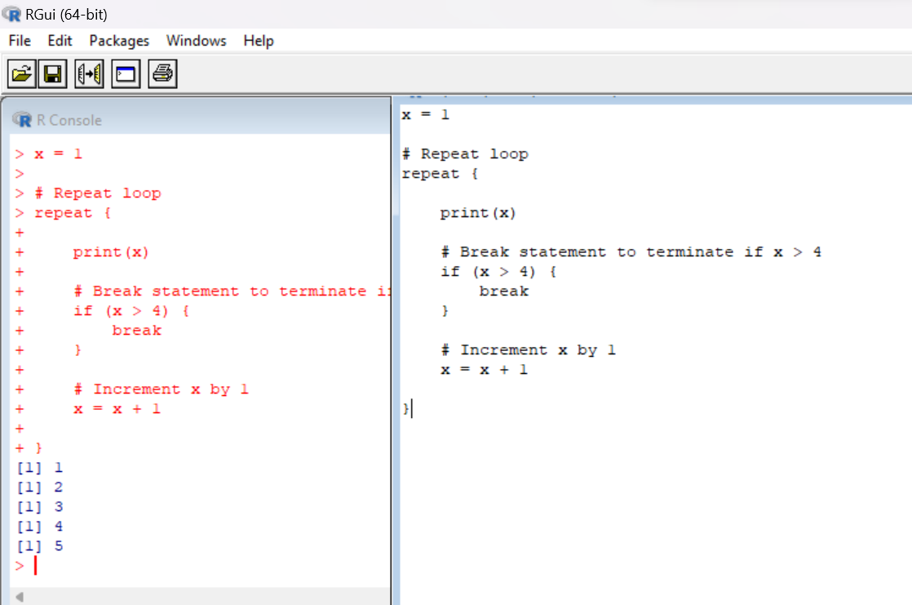  
**RESULT:**

**5.Using functions develop a simple calculator in R.**

**AIM:**

**PROCEDURE:**

**CODE:**

num1=2

num2=12

# Menu for the user to choose an operation

cat("Select an operation:\n")

cat("1. Addition\n")

cat("2. Subtraction\n")

cat("3. Multiplication\n")

cat("4. Division\n")

option <- as.integer(readline("Enter your choice (1-4): "))

# Function to add two numbers

add <- function(a, b) {

return(a + b)

}

# Function to subtract two numbers

subtract <- function(a, b) {

return(a - b)

}

# Function to multiply two numbers

multiply <- function(a, b) {

return(a * b)

}

# Function to divide two numbers

divide <- function(a, b) {

return(a / b)

}

# Get input from the user

# Function to add two numbers

add <- function(a, b) {

return(a + b)

}

# Function to subtract two numbers

subtract <- function(a, b) {

return(a - b)

}

# Function to multiply two numbers

multiply <- function(a, b) {

return(a * b)

}

# Function to divide two numbers

divide <- function(a, b) {

return(a / b)

}

# Get input from the user

num1=12

num2=2

# Menu for the user to choose an operation

cat("Select an operation:\n")

cat("1. Addition\n")

cat("2. Subtraction\n")

cat("3. Multiplication\n")

cat("4. Division\n")

option <- as.integer(readline("Enter your choice (1-4): "))

# Perform the selected operation

result <- switch(option,

add(num1, num2),

subtract(num1, num2),

multiply(num1, num2),

divide(num1, num2))

# Display the result

cat("The result is:", result)

# Perform the selected operation

result <- switch(option,

add(num1, num2),

subtract(num1, num2),

multiply(num1, num2),

divide(num1, num2))

# Display the result

cat("The result is:", result)

**OUTPUT:**

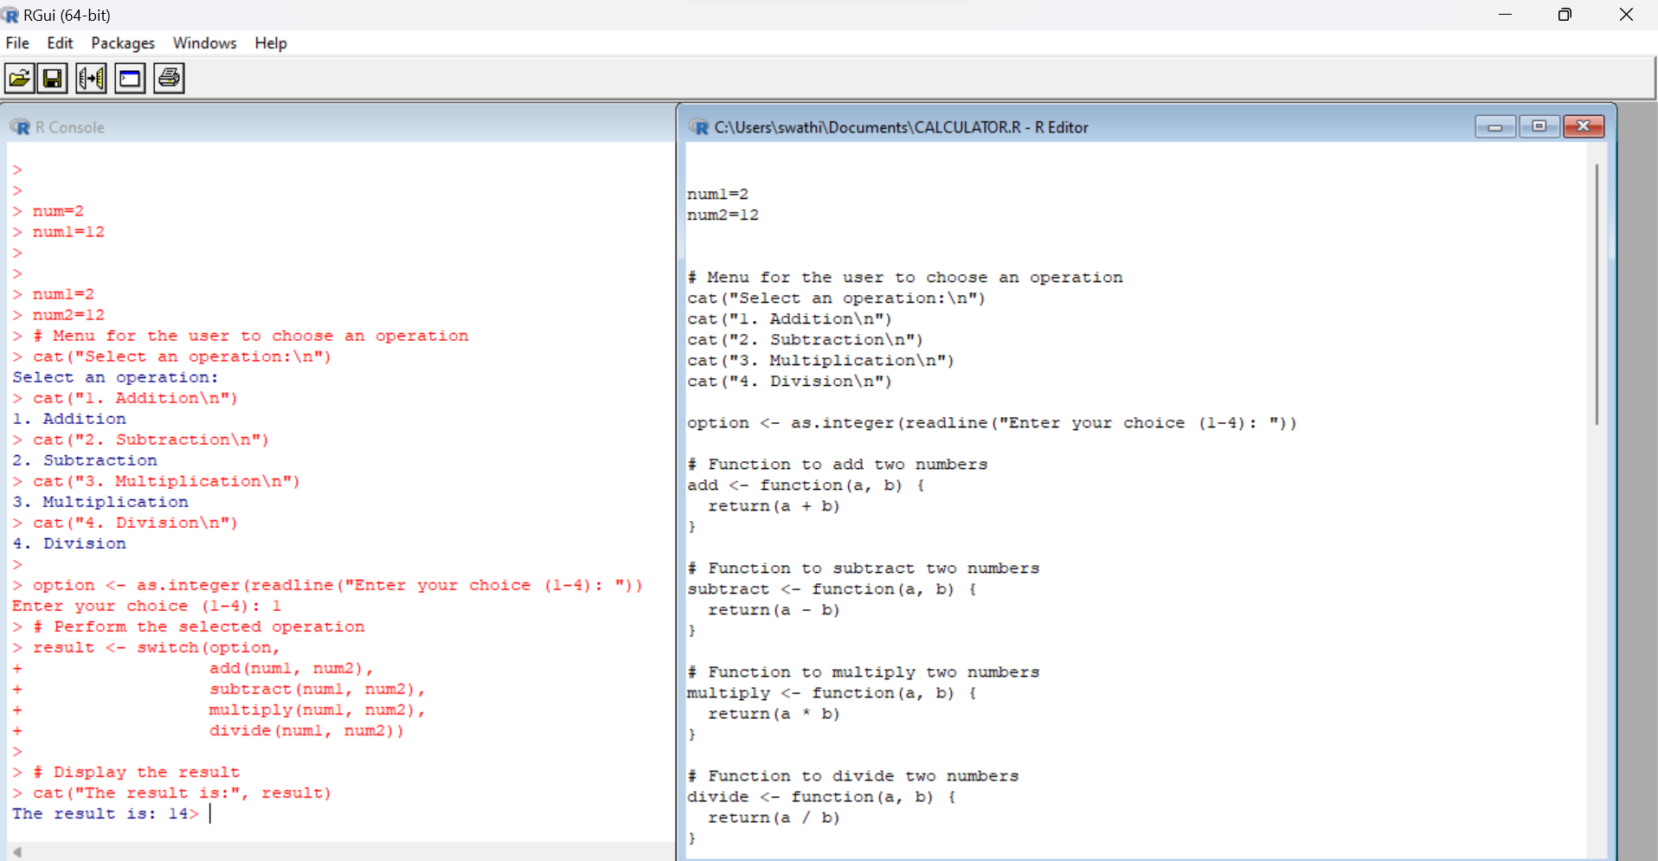

**RESULT:**

**6. Demonstrate the creation of a complex number in R.**

**AIM:**

**PROCEDURE:**

**CODE:**

# Create a complex number using complex() function

complex_num_1 <- complex(real = 2, imaginary = 3)

cat("Complex number 1:", complex_num_1, "\n")

**OUTPUT:**

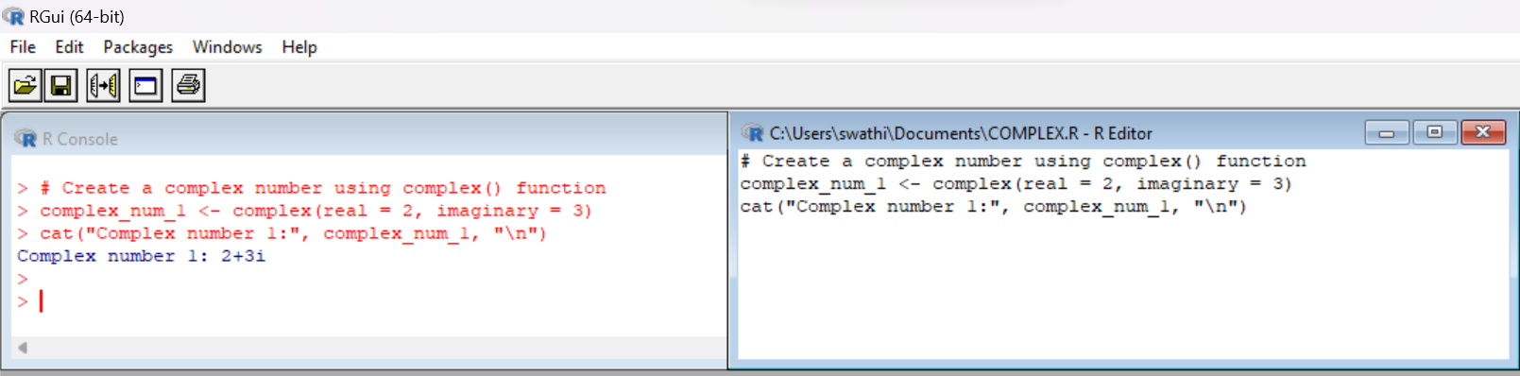

**RESULT:**

**7.Write a program to multiply two numbers using a function with a default value. Assume default value as NULL.**

**AIM:**

**PROCEDURE:**

**CODE:**

multiply_numbers <- function(a, b = NULL) {

if (is.null(b)) {

print("Error: Second number is missing.")

} else {

product <- a * b

return(product)

}

}

# Example usage

result1 <- multiply_numbers(5, 3) # Multiply 5 and 3

print(result1) # Output: 15

result2 <- multiply_numbers(2) # Error: Second number is missing

**OUTPUT:**

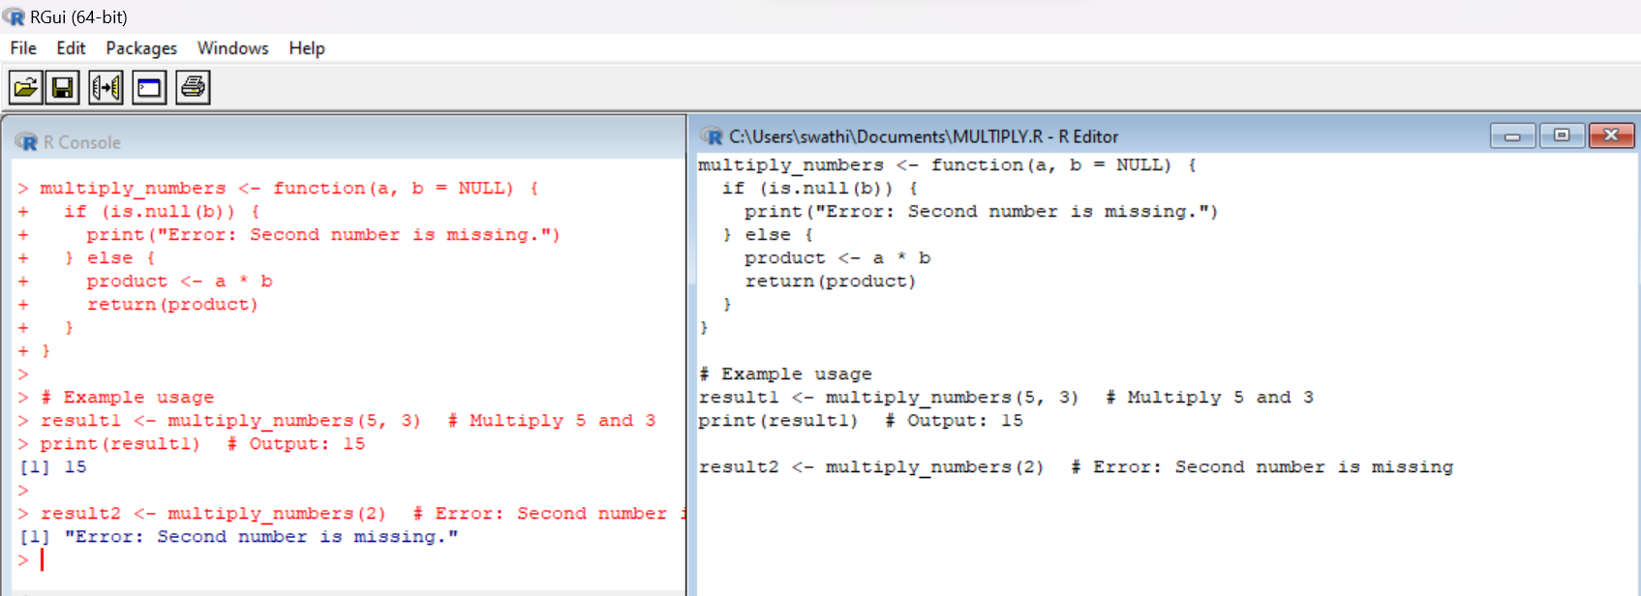

**RESULT:**

**8.Find sum, mean and product of vector elements using built-in functions.**

**AIM:**

**PROCEDURE:**

**CODE:**

# Create a sample vector

v <- c(2, 4, 6, 8, 10)

# Sum of vector elements

sum_v <- sum(v)

cat("Sum of vector elements: ", sum_v, "\n")

# Mean of vector elements

mean_v <- mean(v)

cat("Mean of vector elements: ", mean_v, "\n")

# Product of vector elements

prod_v <- prod(v)

cat("Product of vector elements: ", prod_v, "\n")

**OUTPUT:**

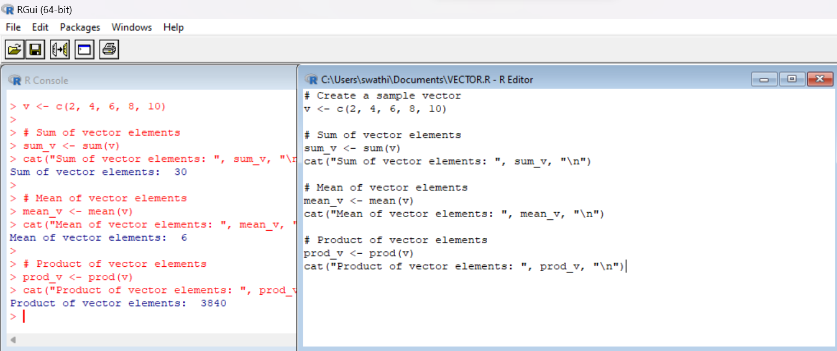

**RESULT:**

**9.Sort a vector in R using sort() function. Also find the index of the sorted vector.**

**AIM:**

**PROCEDURE:**

**CODE:**

# Create a vector

my_vector <- c(8, 3, 1, 6, 2)

# Sort the vector

sorted_vector <- sort(my_vector)

# Find the index of the sorted vector

index <- order(my_vector)

# Print the sorted vector and its index

print(sorted_vector)

print(index)

**OUTPUT:**

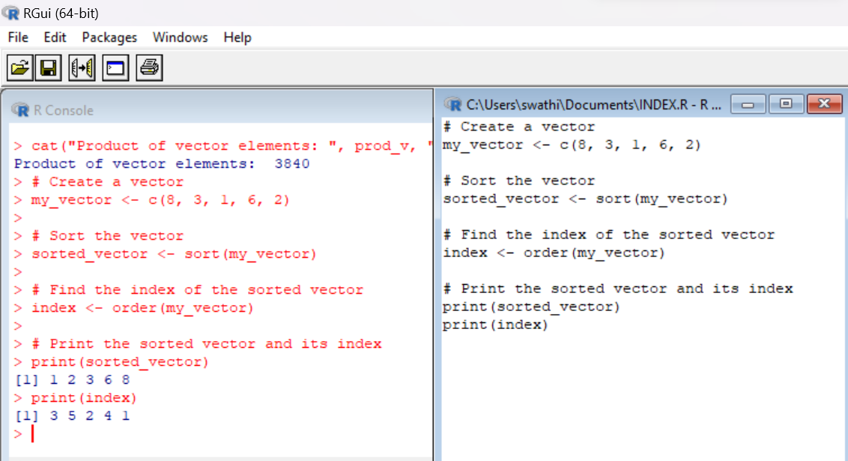

**RESULT:**

**10.Find the L.C.M of two numbers entered by the user by creating a user-defined function.**

**AIM:**

**PROCEDURE:**

**CODE:**

# Function to calculate the LCM of two numbers

calculate_lcm <- function(a, b) {

# Find the maximum of the two numbers

max_num <- max(a, b)

# Initialize lcm variable

lcm <- max_num

while (TRUE) {

# Check if lcm is divisible by both numbers

if (lcm %% a == 0 && lcm %% b == 0) {

break # Found the LCM, exit the loop

}

# Increment lcm by the maximum number

lcm <- lcm + max_num

}

return(lcm)

}

# Get input from the user

num1 <- as.integer(readline("Enter the first number: "))

num2 <- as.integer(readline("Enter the second number: "))2

# Call the function to calculate the LCM

result <- calculate_lcm(num1, num2)

# Print the result

cat("The LCM of", num1, "and", num2, "is", result, "\n")

**OUTPUT:**

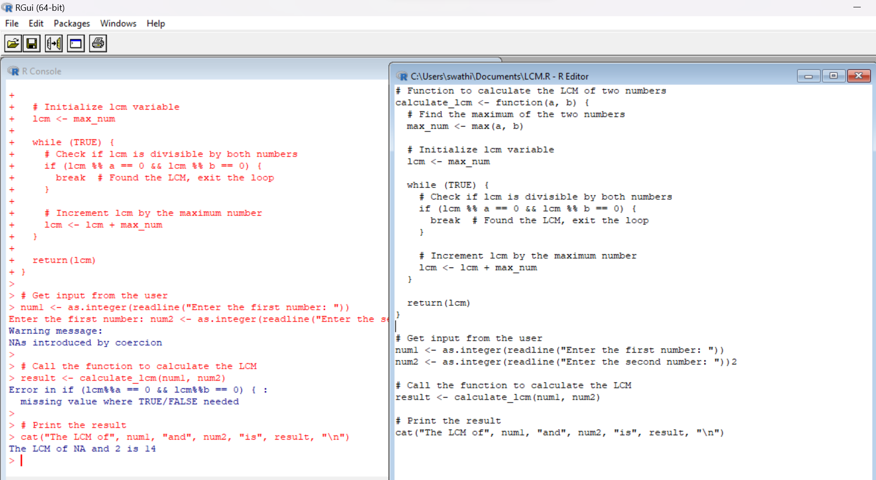

**RESULT:**

**D. IMPLEMENTATION OF VECTOR RECYCLING, APPLY FAMILY & RECURSION**

1. **Demonstrate Vector Recycling in R.**

**AIM:**

**PROCEDURE:**

|  |  |
| --- | --- |
| **CODE:**  a<-c(23,45,67,89)  b<-c(4,5)  print(a+b) | **OUTPUT:**  27 50 71 94 |

**RESULT:**

**2.Demonstrate the usage of apply function in R**

**AIM:**

**PROCEDURE:**

|  |  |
| --- | --- |
| **CODE:**  m<- matrix((1:12), nrow=3)  print(m)  print(apply(m,1,max))  print(apply(m,2,sum)) | **OUTPUT:**  [,1] [,2] [,3] [,4]  [1,] 1 4 7 10  [2,] 2 5 8 11  [3,] 3 6 9 12  > print(apply(m,1,max))  [1] 10 11 12  > print(apply(m,2,sum))  [1] 6 15 24 33 |

**RESULT:**

**3.Demonstrate the usage of lapply function in R**

**AIM:**

**PROCEDURE:**

|  |  |
| --- | --- |
| **CODE:**  names <- c("nikitha", "abhi","pawan",  "hitler","deva")  print( "original data:")  names  # apply lapply() function  print("data after lapply():")  lapply(names, toupper) | **OUTPUT:**  [1] "nikitha" "abhi" "pawan" "hitler" "deva"  [[1]]  [1] "NIKITHA"  [[2]]  [1] "ABHI"  [[3]]  [1] "PAWAN"  [[4]]  [1] "HITLER"  [[5]]  [1] "DEVA" |

**RESULT:**

**4. Demonstrate the usage of sapply function in R**

**AIM:**

**PROCEDURE:**

|  |  |
| --- | --- |
| **CODE:**  sample_data<- data.frame( x=c(1,2,3,4,5,6),y=c(3,2,4,2,34,5))  print( "original data:")  sample_data  # apply sapply() function  print("data after sapply():")  sapply(sample_data, max) | **OUTPUT:**  x y  1 1 3  2 2 2  3 3 4  4 4 2  5 5 34  6 6 5  [1] "data after sapply():"  > sapply(sample_data, max)  x y  6 34 |

**RESULT:**

**5. Demonstrate the usage of tapply function in R**

**AIM:**

**PROCEDURE:**

**CODE:**

# load library tidyverse

library(tidyverse)

# print head of diamonds dataset

print(" Head of data:")

head(diamonds)

# apply tapply function to get average price by cut

print("Average price for each cut of diamond:")

tapply(diamonds$price, diamonds$cut, mean)

**OUTPUT:**

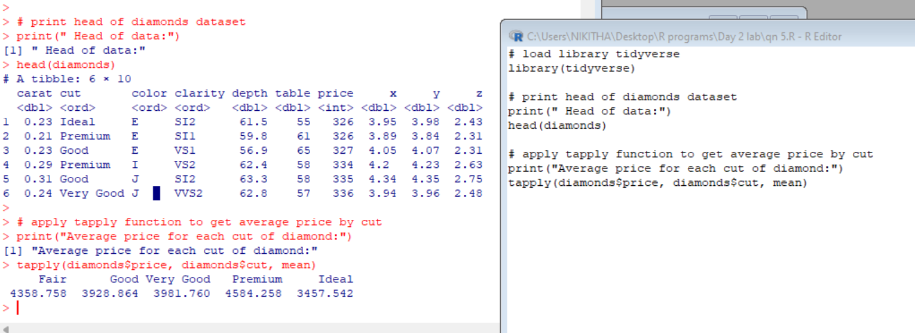

**RESULT:**

**6. Demonstrate the usage of mapply function in R**

**AIM:**

**PROCEDURE:**

**CODE:**

mapply(rep, 1:3, times=5)

**OUTPUT:**

[,1] [,2] [,3]

[1,] 1 2 3

[2,] 1 2 3

[3,] 1 2 3

[4,] 1 2 3

[5,] 1 2 3

**RESULT:**

**7. Sum of Natural Numbers using Recursion**

**AIM:**

**PROCEDURE:**

**CODE & OUTPUT:**

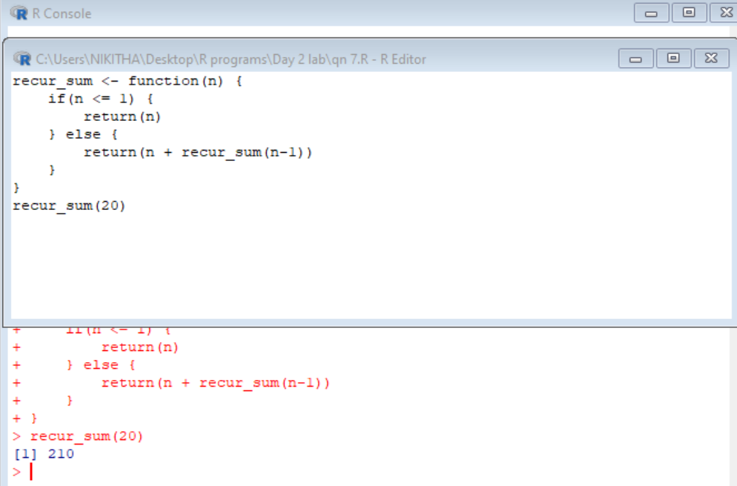

**RESULT:**

**8. Write a program to generate Fibonacci sequence using Recursion in R**

**AIM:**

**PROCEDURE:**

**CODE:**

fibonacci <- function(n) {

if(n <= 1) {

return(n)

} else {

return(fibonacci(n-1) + fibonacci(n-2))

}

}

for(i in 0:10) {

result <- fibonacci(i)

cat(result, " ")

}

**OUTPUT:**

1. 1 1 2 3 5 8 13 21 34 55

**RESULT:**

**9. Write a program to find factorial of a number in R using recursion.**

**AIM:**

**PROCEDURE:**

**CODE:**

factorial <- function(n) {

if(n <= 1) {

return(1)

} else {

return(n * factorial(n-1))

}

}

result <- factorial(9)

cat("9! =", result)

**OUTPUT:**

9!=362880

**RESULT:**

**E. CREATION AND MANIPULATION OF DATAFRAMES IN R**

**1. Consider two vectors: x=seq(1,43,along.with=Id) y=seq(-20,0,along.with=Id)**

**Create a data frame ‘df’ as shown below.**

>df

Id Letter x y

1 1 a 1.000000 -20.000000

2 1 b 4.818182 -18.181818

3 1 c 8.636364 -16.363636

4 2 a 12.454545 -14.545455

5 2 b 16.272727 -12.727273

6 2 c 20.090909 -10.909091

7 3 a 23.909091 -9.090909

8 3 b 27.727273 -7.272727

9 3 c 31.545455 -5.454545

10 4 a 35.363636 -3.636364

11 4 b 39.181818 -1.818182

12 4 c 43.000000 0.000000

**AIM:**

**PROCEDURE:**

**CODE:**

x <- seq(1, 43, along.with = Id)

y <- seq(-20, 0, along.with = Id)

letters <- c("a", "b", "c")

df <- data.frame(Id = rep(1:4, each = 3),

Letter = rep(letters, 4),

x = x,

y = y)

df

**OUTPUT:**

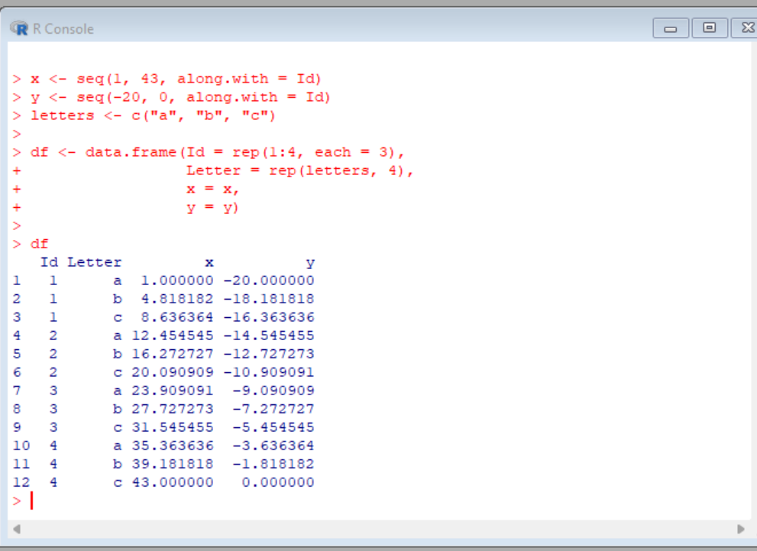

**RESULT:**

**2. Create two data frame df1 and df2:**

> df1

Id Age

1. 1 14
2. 2 12
3. 3 15
4. 4 10

> df2

Id Sex Code

1. 1 F a
2. 2 M b
3. 3 M c
4. 4 F d

From df1 and df2 create M:

>M

Id Age Sex Code

1. 1 14 F a
2. 2 12 M b
3. 3 15 M c 4 4 10 F d

**AIM:**

**PROCEDURE:**

**CODE:**

# Create df1

df1 <- data.frame(Id = 1:4,

Age = c(14, 12, 15, 10))

df1

# Create df2

df2 <- data.frame(Id = 1:4,

Sex = c("F", "M", "M", "F"),

Code = c("a", "b", "c", "d"))

df2

# Combine df1 and df2 into M

M <- merge(df1, df2)

M

**OUTPUT:**

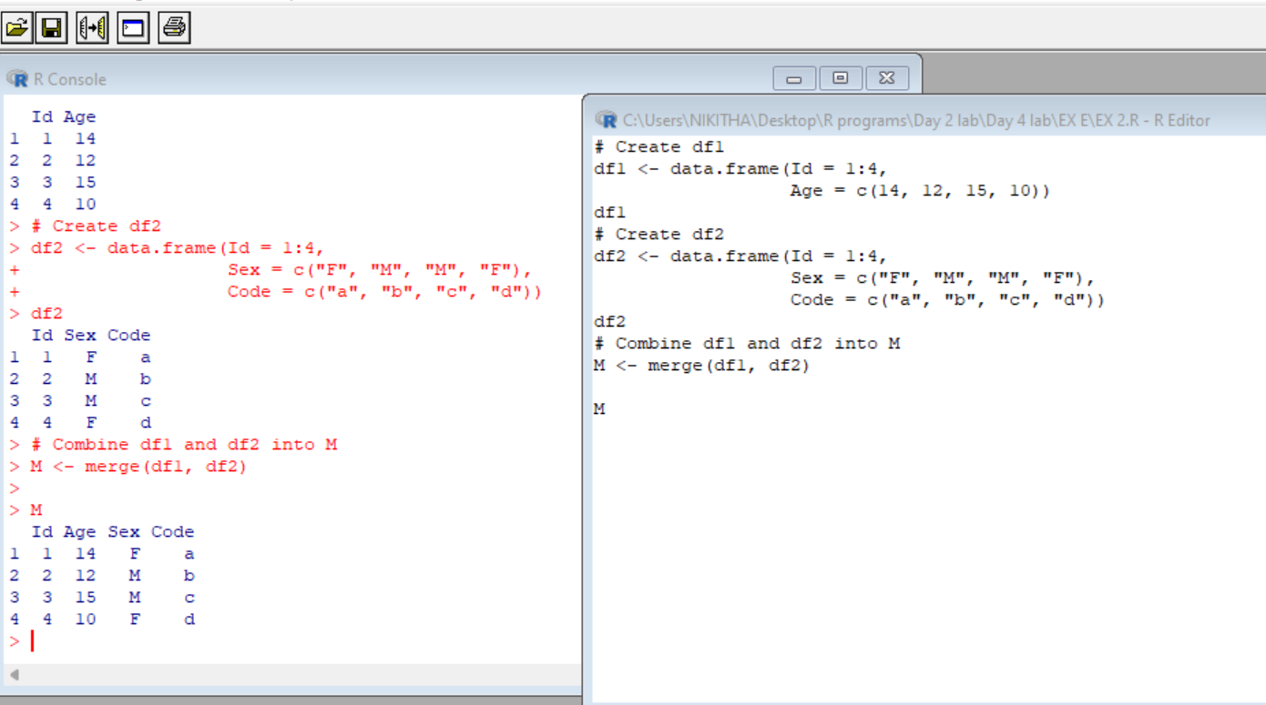

**RESULT:**

## **3. Create a data frame df3:**

> df3 id2 score 1 4 100

1. 3 98
2. 2 94
3. 1 99

From M (used in Exercise-3) and df3 create N:

Id Age Sex Code score

1. 1 14 F a 99
2. 2 12 M b 94
3. 3 15 M c 98 4 4 10 F d 100

**AIM:**

**PROCEDURE:**

**CODE:**

# Create df1

df1 <- data.frame(Id = 1:4,

Age = c(14, 12, 15, 10))

# Create df2

df2 <- data.frame(Id = 1:4,

Sex = c("F", "M", "M", "F"),

Code = c("a", "b", "c", "d"))

# Combine df1 and df2 into M

M <- merge(df1, df2)

M

# Create df3

df3 <- data.frame(id2 = c(4, 3, 2, 1),

score = c(100, 98, 94, 99))

df3

# Combine M and df3 into N

N <- merge(M, df3, by.x = "Id", by.y = "id2")

N

**OUTPUT:**

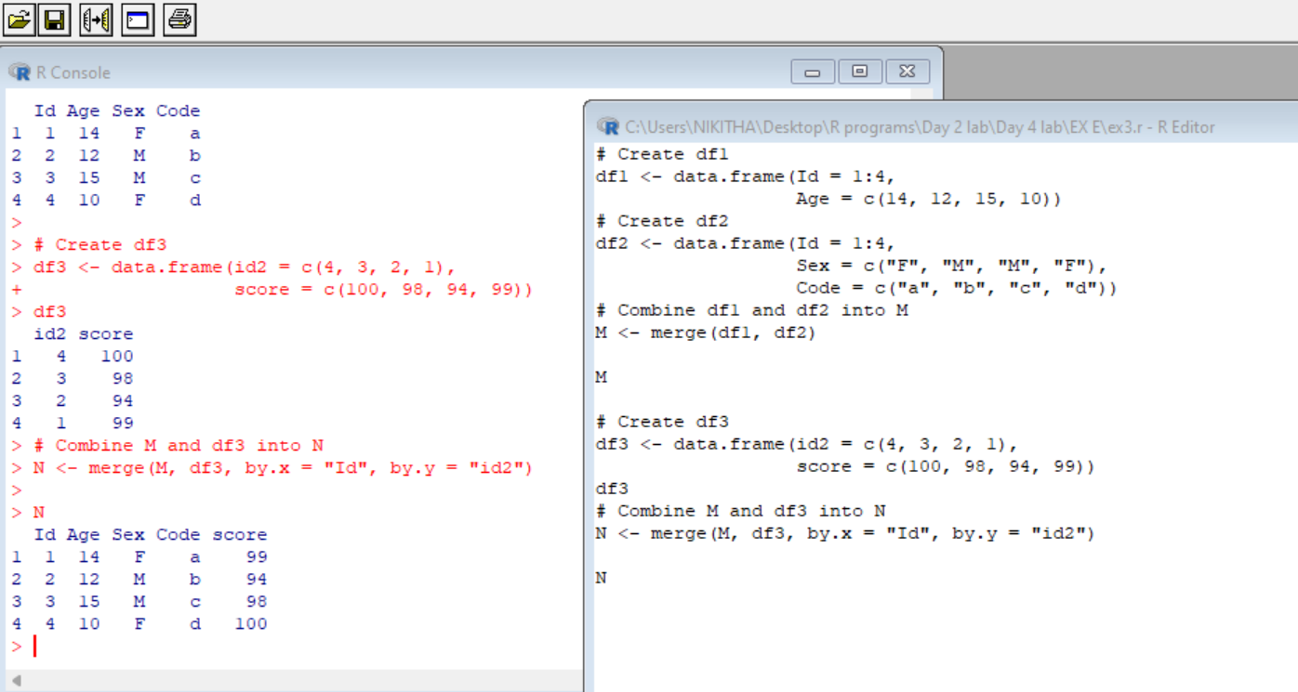

**RESULT:**

## **4. Consider the previous one data frame N:**

**1) Remove the variables Sex and Code**

**2) From N, create a data frame:**

values ind

1. 1 Id
2. 2 Id
3. 3 Id
4. 4 Id
5. 14 Age
6. 12 Age
7. 15 Age
8. 10 Age
9. 99 score
10. 94 score
11. 98 score
12. 100 score

**AIM:**

**PROCEDURE:**

**CODE:**

# Create df1

df1 <- data.frame(Id = 1:4,

Age = c(14, 12, 15, 10))

# Create df2

df2 <- data.frame(Id = 1:4,

Sex = c("F", "M", "M", "F"),

Code = c("a", "b", "c", "d"))

# Combine df1 and df2 into M

M <- merge(df1, df2)

M

# Create df3

df3 <- data.frame(id2 = c(4, 3, 2, 1),

score = c(100, 98, 94, 99))

df3

# Combine M and df3 into N

N <- merge(M, df3, by.x = "Id", by.y = "id2")

N

# Remove variables Sex and Code from N

N_updated <- subset(N, select = -c(Sex, Code))

# Create a new data frame with the desired structure

new_df <- data.frame(values = c(N_updated$Id, N_updated$Age, N_updated$score),

ind = rep(c("Id", "Age", "score"), each = nrow(N_updated)))

new_df

**OUTPUT**:

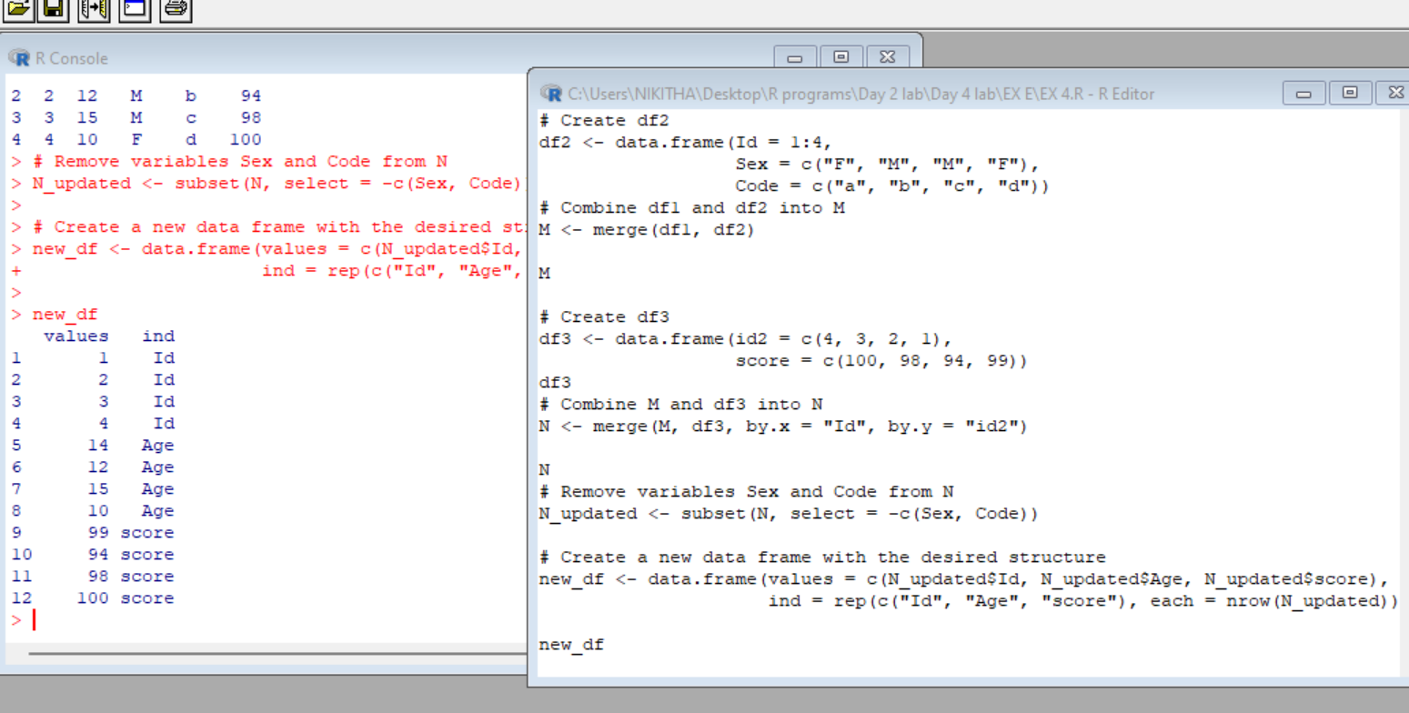

**RESULT:**

## **6. For this exercise, we’ll use the (built-in) dataset trees.**

1. **Make sure the object is a data frame, if not change it to a data frame.**
2. **Create a new data frame A:**

>A

Girth Height Volume

mean_tree 13.24839 76 30.17097

min_tree 8.30000 63 10.20000

max_tree 20.60000 87 77.00000

sum_tree 410.70000 2356 935.30000

**AIM:**

**PROCEDURE:**

**CODE:**

# Check if the object is a data frame and convert it if necessary

if (!is.data.frame(trees)) {

trees <- as.data.frame(trees)

}

# Create the new data frame A

A <- data.frame(Girth = c(mean(trees$Girth), min(trees$Girth), max(trees$Girth), sum(trees$Girth)),

Height = c(mean(trees$Height), min(trees$Height), max(trees$Height), sum(trees$Height)),

Volume = c(mean(trees$Volume), min(trees$Volume), max(trees$Volume), sum(trees$Volume)))

# Assign row names to A

row.names(A) <- c("mean_tree", "min_tree", "max_tree", "sum_tree")

A

**OUTPUT:**

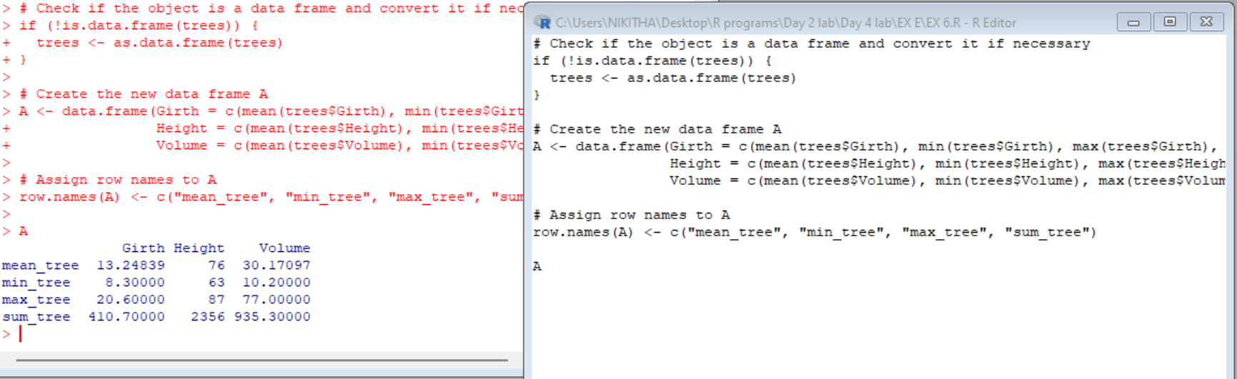

**RESULT:**

## **7. Consider the data frame A:**

a)Order the entire data frame by the first column.

b)Rename the row names as follows: mean, min, max, tree

**AIM:**

**PROCEDURE:**

**CODE:**

# Check if the object is a data frame and convert it if necessary

if (!is.data.frame(trees)) {

trees <- as.data.frame(trees)

}

# Create the new data frame A

A <- data.frame(Girth = c(mean(trees$Girth), min(trees$Girth), max(trees$Girth), sum(trees$Girth)),

Height = c(mean(trees$Height), min(trees$Height), max(trees$Height), sum(trees$Height)),

Volume = c(mean(trees$Volume), min(trees$Volume), max(trees$Volume), sum(trees$Volume)))

# Assign row names to A

row.names(A) <- c("mean_tree", "min_tree", "max_tree", "sum_tree")

# Order the data frame by the first column

A_ordered <- A[order(A[, 1]), ]

# Rename the row names

row.names(A_ordered) <- c("mean", "min", "max", "tree")

A_ordered

**OUTPUT:**

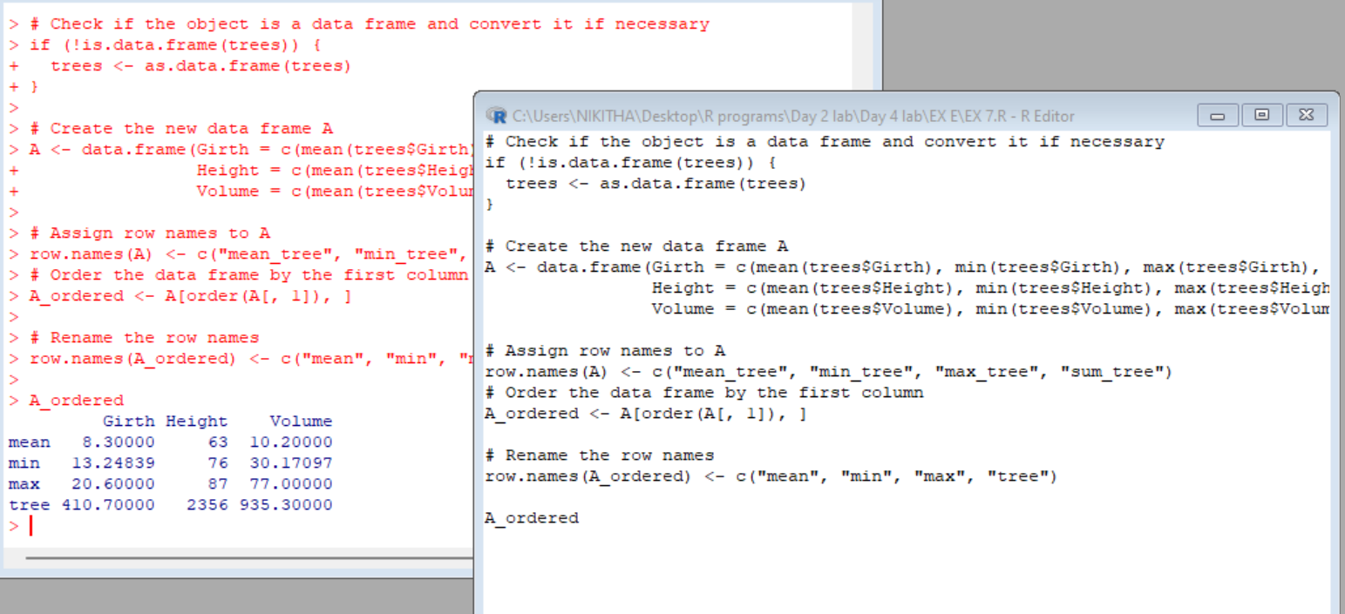

**RESULT:**

**8. Create a data frame XY**

X=c(1,2,3,1,4,5,2)

Y=c(0,3,2,0,5,9,3)

> XY

X Y

1 0

2 3

3 2

1 0

4 5

5 9

2 3

look at duplicated elements using a provided R function. keep only the unique lines on XY using a provided R function.

**AIM:**

**PROCEDURE:**

**CODE:**

# Create the vectors X and Y

X <- c(1, 2, 3, 1, 4, 5, 2)

Y <- c(0, 3, 2, 0, 5, 9, 3)

# Create the data frame XY

XY <- data.frame(X, Y)

# Check for duplicated elements using the duplicated() function

duplicated_rows <- duplicated(XY)

# Keep only the unique lines in XY using the unique() function

XY_unique <- unique(XY)

XY_unique

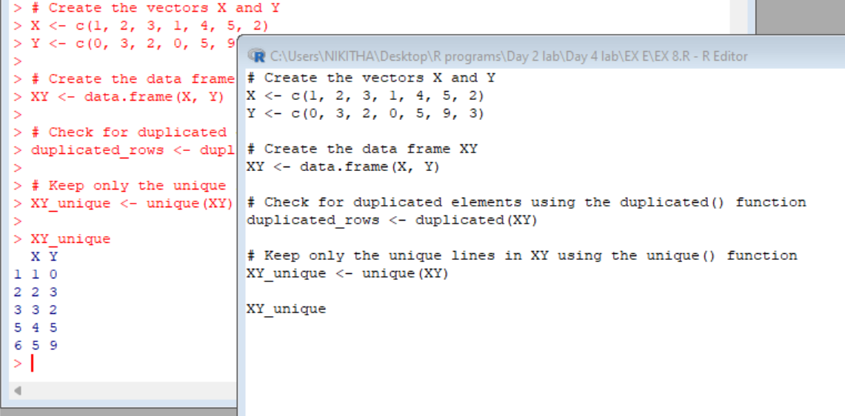

**9. Use the (built-in) dataset Titanic.**

Make sure the object is a data frame, if not change it to a data frame.

Define a data frame with value 1st in Class variable, and value NO in Survived variable and variables Sex, Age and Freq.

Sex Age Freq

1 Male Child 0

5 Female Child 0

9 Male Adult 118

1. Female Adult 4

**AIM:**

**PROCEDURE:**

**CODE:**

# Check if the object is a data frame and convert it if necessary

if (!is.data.frame(Titanic)) {

Titanic <- as.data.frame(Titanic)

}

# Define the new data frame with the specified values

new_df <- data.frame(Sex = c("Male", "Female", "Male", "Female"),

Age = c("Child", "Child", "Adult", "Adult"),

Freq = c(0, 0, 118, 4),

stringsAsFactors = FALSE)

# Set the Class variable to "1st"

new_df$Class <- "1st"

# Set the Survived variable to "NO"

new_df$Survived <- "NO"

new_df

**OUTPUT:**

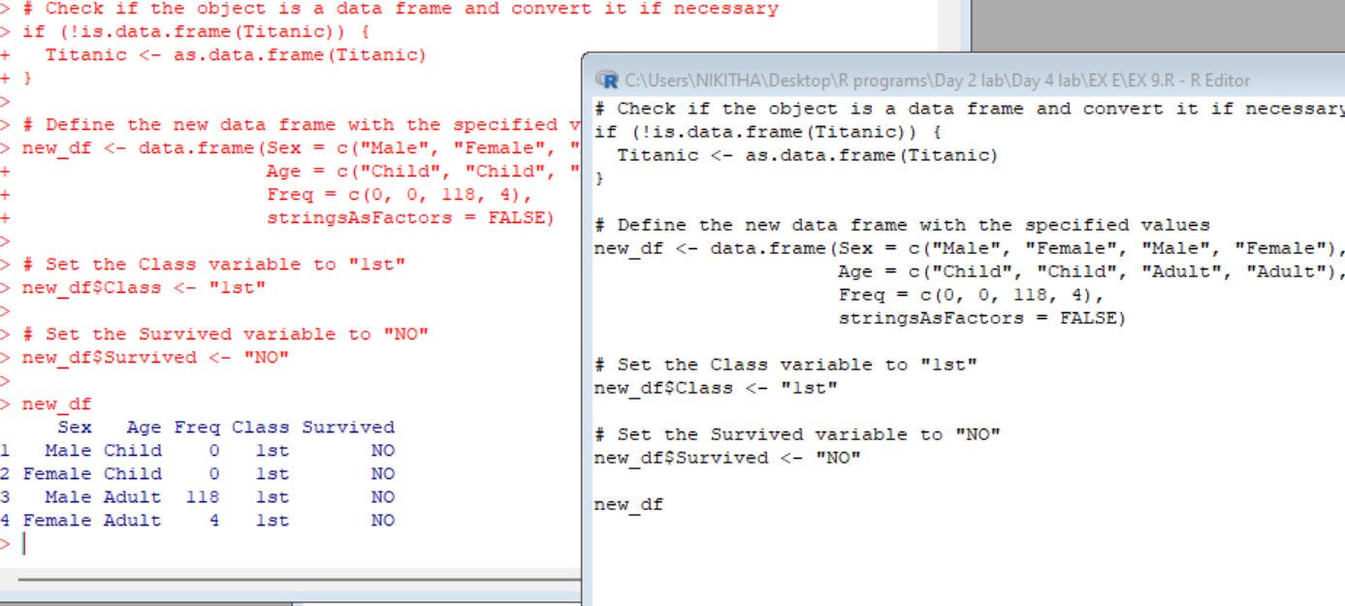

**RESULT:**

**MERGING DATAFRAMES**

10 a) Create the following dataframes to merge:

buildings<- data.frame(location=c(1, 2, 3), name=c("building1", "building2","building3"))

data <- data.frame(survey=c(1,1,1,2,2,2),location=c(1,2,3,2,3,1),efficiency=c(51,64,70,7,80,58))

The dataframes, buildingsand datahave a common key variable called, “location”.

Use the merge() function to merge the two dataframes by “location”, into a new dataframe,“buildingStats”.

**AIM:**

**PROCEDURE:**

**CODE:**

# Create the buildings data frame

buildings <- data.frame(location = c(1, 2, 3), name = c("building1", "building2", "building3"))

# Create the data data frame

data <- data.frame(survey = c(1, 1, 1, 2, 2, 2),

location = c(1, 2, 3, 2, 3, 1),

efficiency = c(51, 64, 70, 7, 80, 58))

# Merge the buildings and data data frames by "location"

buildingStats <- merge(buildings, data, by = "location")

buildingStats

**OUTPUT:**

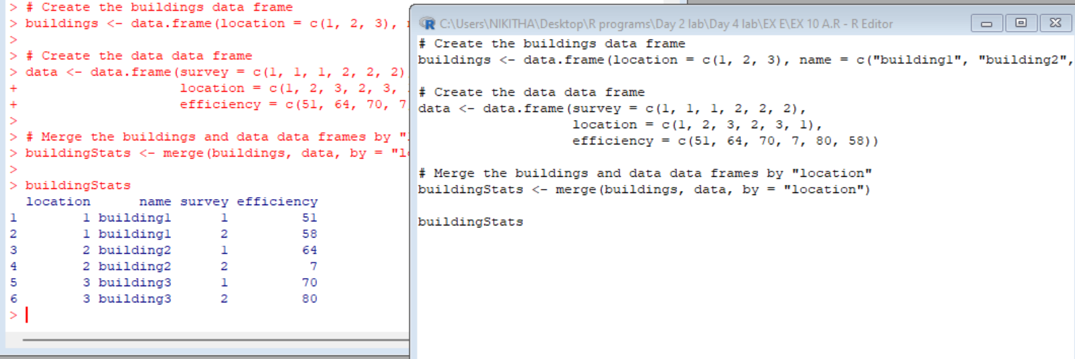

**RESULT:**

1. Give the dataframes different key variable names:

buildings<- data.frame(location=c(1, 2, 3), name=c("building1","building2", "building3"))

data <- data.frame(survey=c(1,1,1,2,2,2), LocationID=c(1,2,3,2,3,1), efficiency=c(51,64,70,71,80,58))

The dataframes, buildings and data have corresponding variables called, location, and LocationID. Use the merge() function to merge the columns of the two dataframes by the corresponding variables.

**AIM:**

**PROCEDURE:**

**CODE:**

# Create the buildings data frame

buildings <- data.frame(location = c(1, 2, 3), name = c("building1", "building2", "building3"))

# Create the data data frame

data <- data.frame(survey = c(1, 1, 1, 2, 2, 2),

LocationID = c(1, 2, 3, 2, 3, 1),

efficiency = c(51, 64, 70, 71, 80, 58))

# Merge the buildings and data data frames by the corresponding variables

buildingStats <- merge(buildings, data, by.x = "location", by.y = "LocationID")

buildingStats

**OUTPUT:**

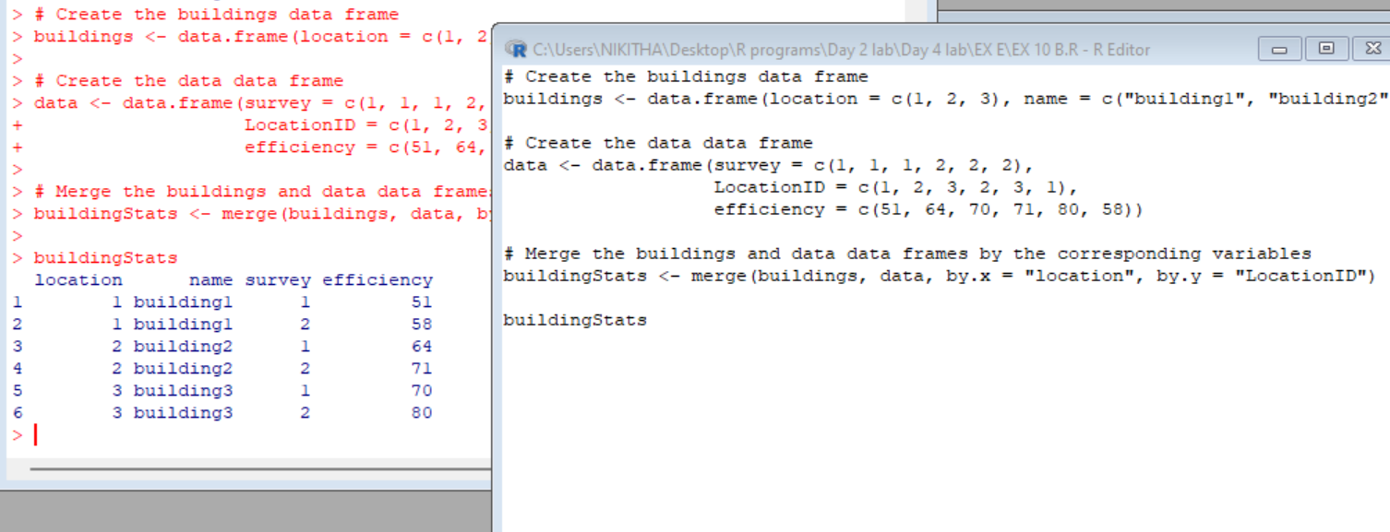

**RESULT:**

**DIFFERENT TYPES OF MERGE IN R**

11 **a)InnerJoin:**

The R merge() function automatically joins the frames by common variable names. In that case, demonstrate how you would perform the merge in Exercise 10 a without specifying the key variable.

**AIM:**

**PROCEDURE:**

**CODE:**

# Create the buildings data frame

buildings <- data.frame(location = c(1, 2, 3), name = c("building1", "building2", "building3"))

# Create the data data frame

data <- data.frame(survey = c(1, 1, 1, 2, 2, 2),

location = c(1, 2, 3, 2, 3, 1),

efficiency = c(51, 64, 70, 7, 80, 58))

# Merge the data frames by "location" using explicit key variable specification

buildingStats <- merge(buildings, data, by = "location")

buildingStats

# Merge the data frames without specifying the key variable

buildingStats_auto <- merge(buildings, data)

buildingStats_auto

**OUTPUT:**

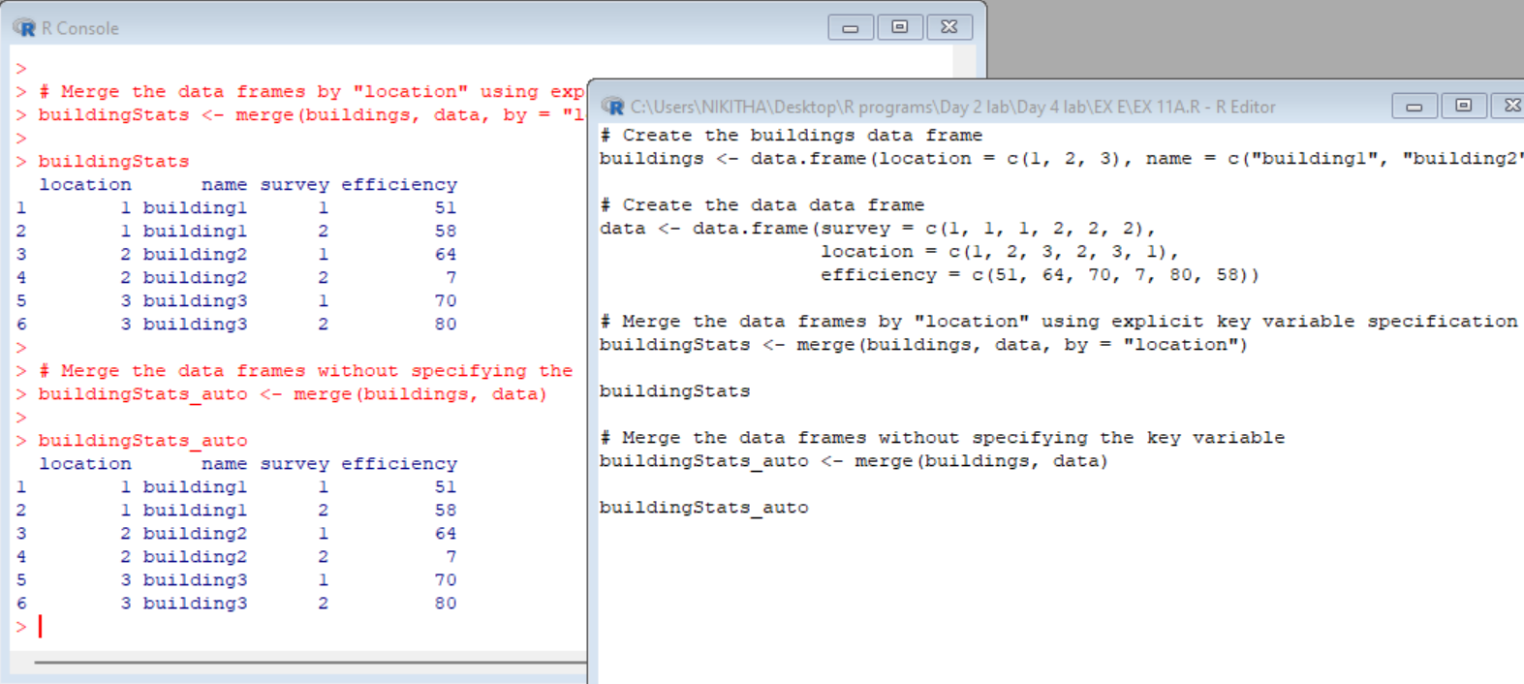

**RESULT:**

**b)OuterJoin:**

Merge the two dataframes from Exercise 10 a. Use the “all=” parameter in the merge() function to return all records from both tables. Also, merge with the key variable, “location”.

**AIM:**

**PROCEDURE:**

**CODE:**

# Create the buildings data frame

buildings <- data.frame(location = c(1, 2, 3), name = c("building1", "building2", "building3"))

# Create the data data frame

data <- data.frame(survey = c(1, 1, 1, 2, 2, 2),

location = c(1, 2, 3, 2, 3, 1),

efficiency = c(51, 64, 70, 7, 80, 58))

# Merge the data frames by "location" using an outer join

buildingStats <- merge(buildings, data, by = "location", all = TRUE)

buildingStats

**OUTPUT:**

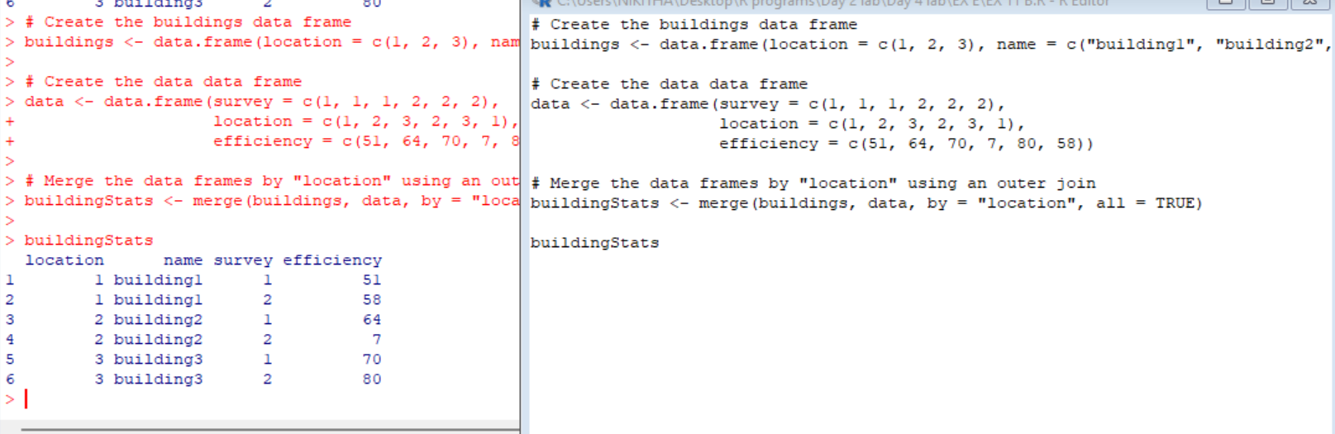

c)Left Join:

Merge the two dataframes from Exercise 10 a, and return all rows from the left table. Specify the matching key from Exercise 10 a.

**AIM:**

**PROCEDURE:**

**CODE:**

# Create the buildings dataframe

buildings <- data.frame(location = c(1, 2, 3), name = c("building1", "building2", "building3"))

# Create the data dataframe

data <- data.frame(survey = c(1, 1, 1, 2, 2, 2), location = c(1, 2, 3, 2, 3, 1), efficiency = c(51, 64, 70, 7, 80, 58))

# Merge the dataframes using left join

buildingStats <- merge(buildings, data, by = "location", all.x = TRUE)

# Print the merged dataframe

BuildingStats

**OUTPUT:**

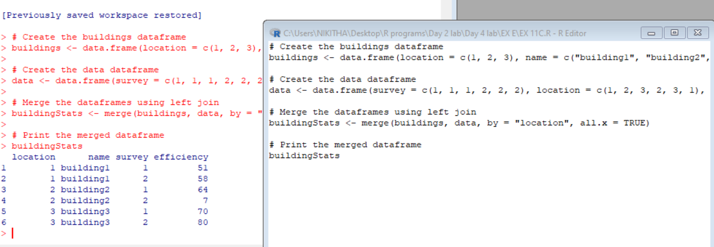

**RESULT:**

**d)Right Join:**

Merge the two dataframes from Exercise 10a, and return all rows from the right table. Use the matching key from Exercise 10a to return matching rows from the left table.

**AIM:**

**PROCEDURE:**

**CODE:**

# Create the buildings dataframe

buildings <- data.frame(location = c(1, 2, 3), name = c("building1", "building2", "building3"))

# Create the data dataframe

data <- data.frame(survey = c(1, 1, 1, 2, 2, 2), location = c(1, 2, 3, 2, 3, 1), efficiency = c(51, 64, 70, 7, 80, 58))

# Merge the dataframes using right join

buildingStats <- merge(buildings, data, by = "location", all.y = TRUE)

# Print the merged dataframe

BuildingStats

**OUTPUT:**

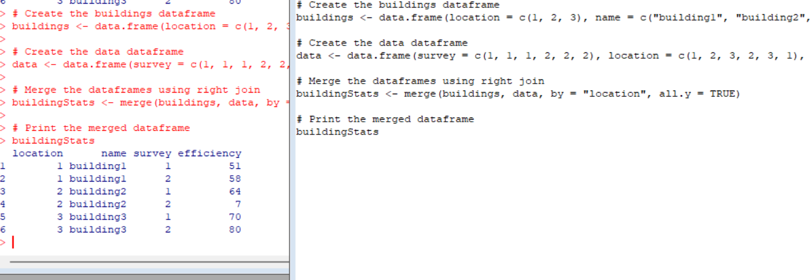

**e)Cross Join:**

Merge the two dataframes from Exercise 10a, into a “Cross Join” with each row of “buildings” matched to each row of “data”. What new column names are created in “buildingStats”?

**AIM:**

**PROCEDURE:**

**CODE:**

# Create the buildings dataframe

buildings <- data.frame(location = c(1, 2, 3), name = c("building1", "building2", "building3"))

# Create the data dataframe

data <- data.frame(survey = c(1, 1, 1, 2, 2, 2), location = c(1, 2, 3, 2, 3, 1), efficiency = c(51, 64, 70, 7, 80, 58))

# Merge the dataframes using cross join

buildingStats <- merge(buildings, data, by=NULL)

# Print the merged dataframe

BuildingStats

**OUTPUT:**

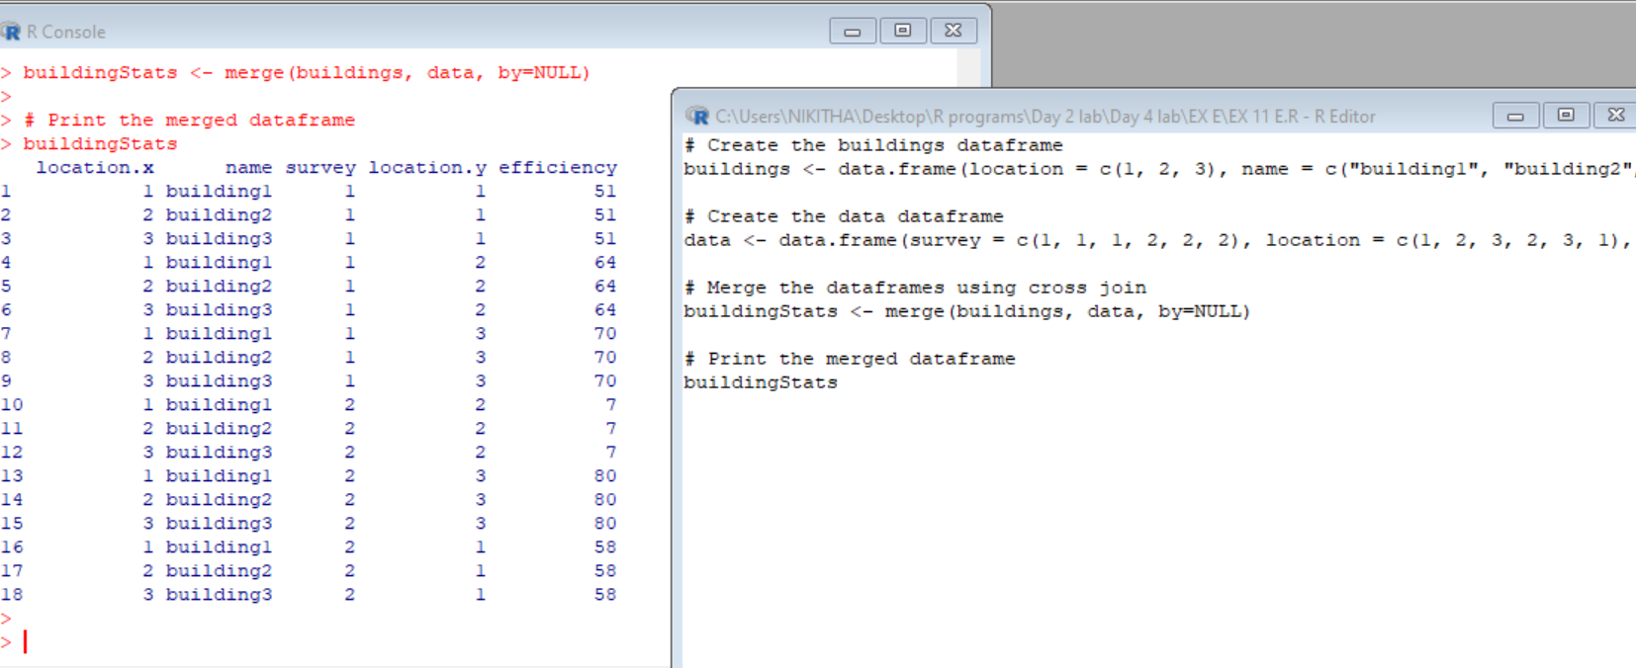

**RESULT:**

**12 MergingDataframe rows:**

To join two data frames (datasets) vertically, use the rbind function. The two data frames must have the same variables, but they do not have to be in the same order.

Merge the rows of the following two dataframes:

buildings<- data.frame(location=c(1, 2, 3), name=c("building1",

"building2", "building3"))

buildings2 <- data.frame(location=c(5, 4, 6), name=c("building5", "building4", "building6"))

Also, specify the new dataframe as, “allBuidings”.

**AIM:**

**PROCEDURE:**

**CODE:**

# Create the buildings dataframe

buildings <- data.frame(location = c(1, 2, 3), name = c("building1", "building2", "building3"))

# Create the buildings2 dataframe

buildings2 <- data.frame(location = c(5, 4, 6), name = c("building5", "building4", "building6"))

# Merge the rows of the dataframes using rbind

allBuildings <- rbind(buildings, buildings2)

# Print the merged dataframe

AllBuildings

**OUTPUT:**

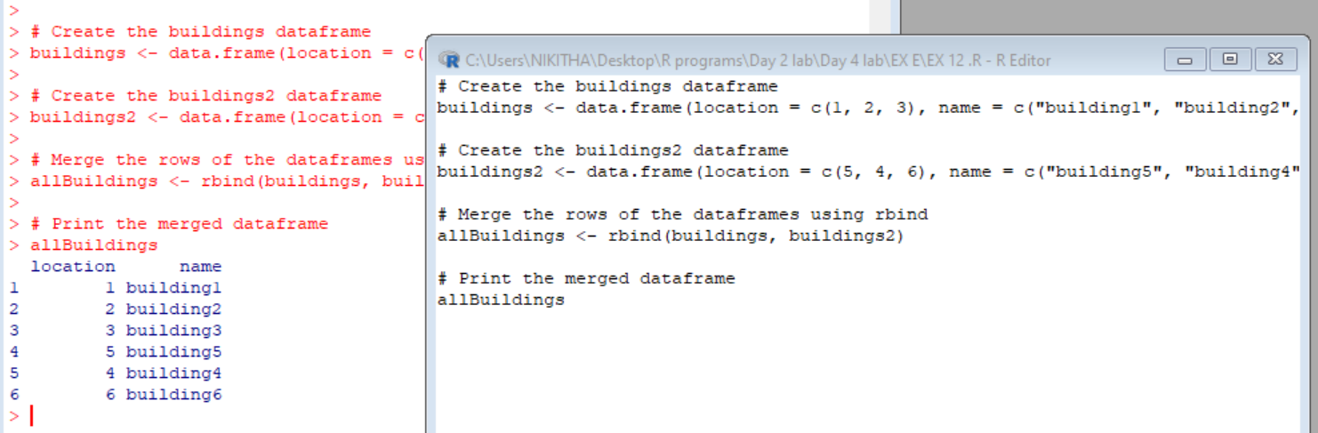

**RESULT:**

**F**. **RESHAPE FUNCTION IN R**

* Construct the following data frame ‘country’.

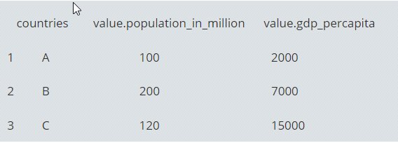

* **Reshape in R from wide to long:**

Reshape the above data frame from wide to long format in R.

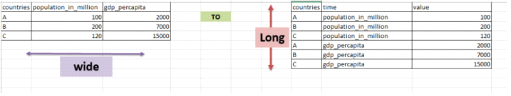

* data frame “country” is passed to reshape function
* idvar is the variable which need to be left unaltered which is “countries”
* varying are the ones that needs to converted from wide to long
* v.names are the values that should be against the times in the resultant [data frame](http://www.datasciencemadesimple.com/data-frame-in-r/).
* new.row.names is used to assign row names to the resultant dataset
* direction is, to which format the data needs to be transformed

**Aim:**

**Procedure:**

**Code:**

> country<-data.frame(c("A","B","C"),c(100,200,120),c(2000,7000,15000))

> colnames(country)<- c("countries","population_in_million","gdp_percapita")

> country

**OUTPUT:**

countries population_in_million gdp_percapita

1 A 100 2000

2 B 200 7000

3 C 120 15000

**Code: Reshape in R from wide to long**

> country_w_to_L<- reshape(data=country, idvar="countries",

+ varying = c("population_in_million","gdp_percapita"),

+ v.name=c("value"),

+ times=c("population_in_million","gdp_percapita"),

+ new.row.names = 1:1000,

+ direction="long")

> country_w_to_L

**OUTPUT:**

countries time value

1 A population_in_million 100

2 B population_in_million 200

3 C population_in_million 120

4 A gdp_percapita 2000

5 B gdp_percapita 7000

6 C gdp_percapita 15000

**Result:**

* **Reshape in R from long to wide:**

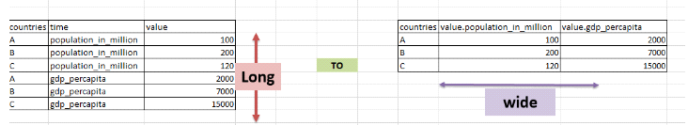

* data (country_w_to_L) which is in long format,  is passed to reshape function
* idvar is the variable which need to be left unaltered, which is “countries”
* timevar are the variables that needs to converted to wide format
* v.names are the value variable
* direction is, to which format the data needs to be transformed

**Aim:**

**Procedure:**

**Code:**

library(tidyr)

data_long = gather(country, detail, value, population_in_million:gdp_percapita, factor_key=TRUE)

data_long

**OUTPUT:**

countries detail value

1 A population_in_million 100

2 B population_in_million 200

3 C population_in_million 120

4 A gdp_percapita 2000

5 B gdp_percapita 7000

6 C gdp_percapita 15000

**Result:**

1. **MELTING AND CASTING IN R**

1. **Melt airquality data set and display as a long – format data ?**

**Aim** :

**Procedure :**

**Code & Output :**

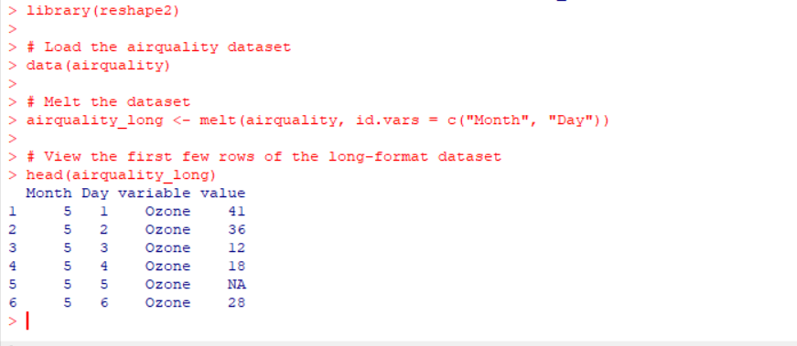

**RESULT :**

**2.Melt airquality data and specify month and day to be “ID variables” ?**

**AIM :**

**Procedure :**

**Code & Output :**

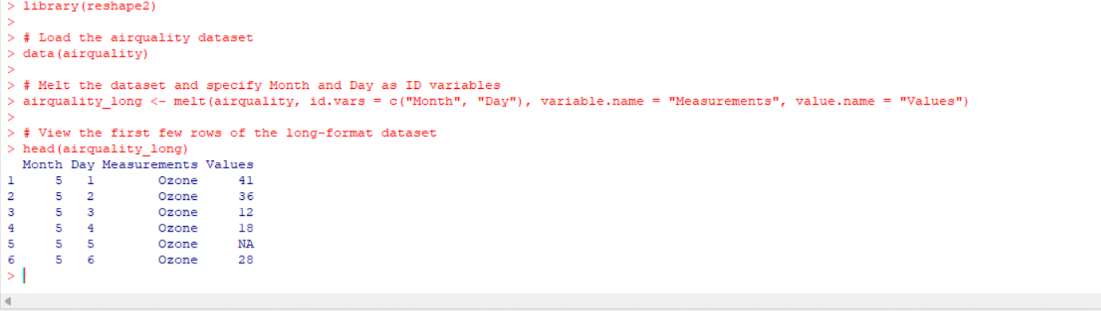

**Result :**

**3.Cast the molten airquality data set .**

**Aim :**

**Procedure :**

**Code & Output :**

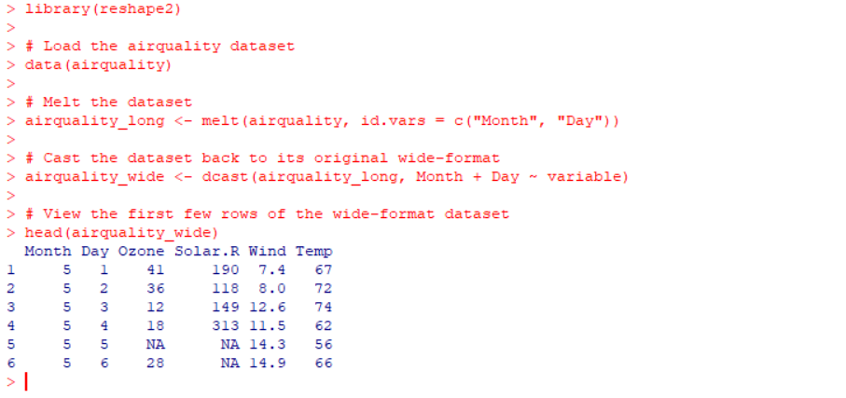

**Result :**

**4.Use cast function appropriately and compute the average of Ozone, Solar.R , Wind and temperature per month ?**

**Aim :**

**Procedure :**

**Code & Output :**

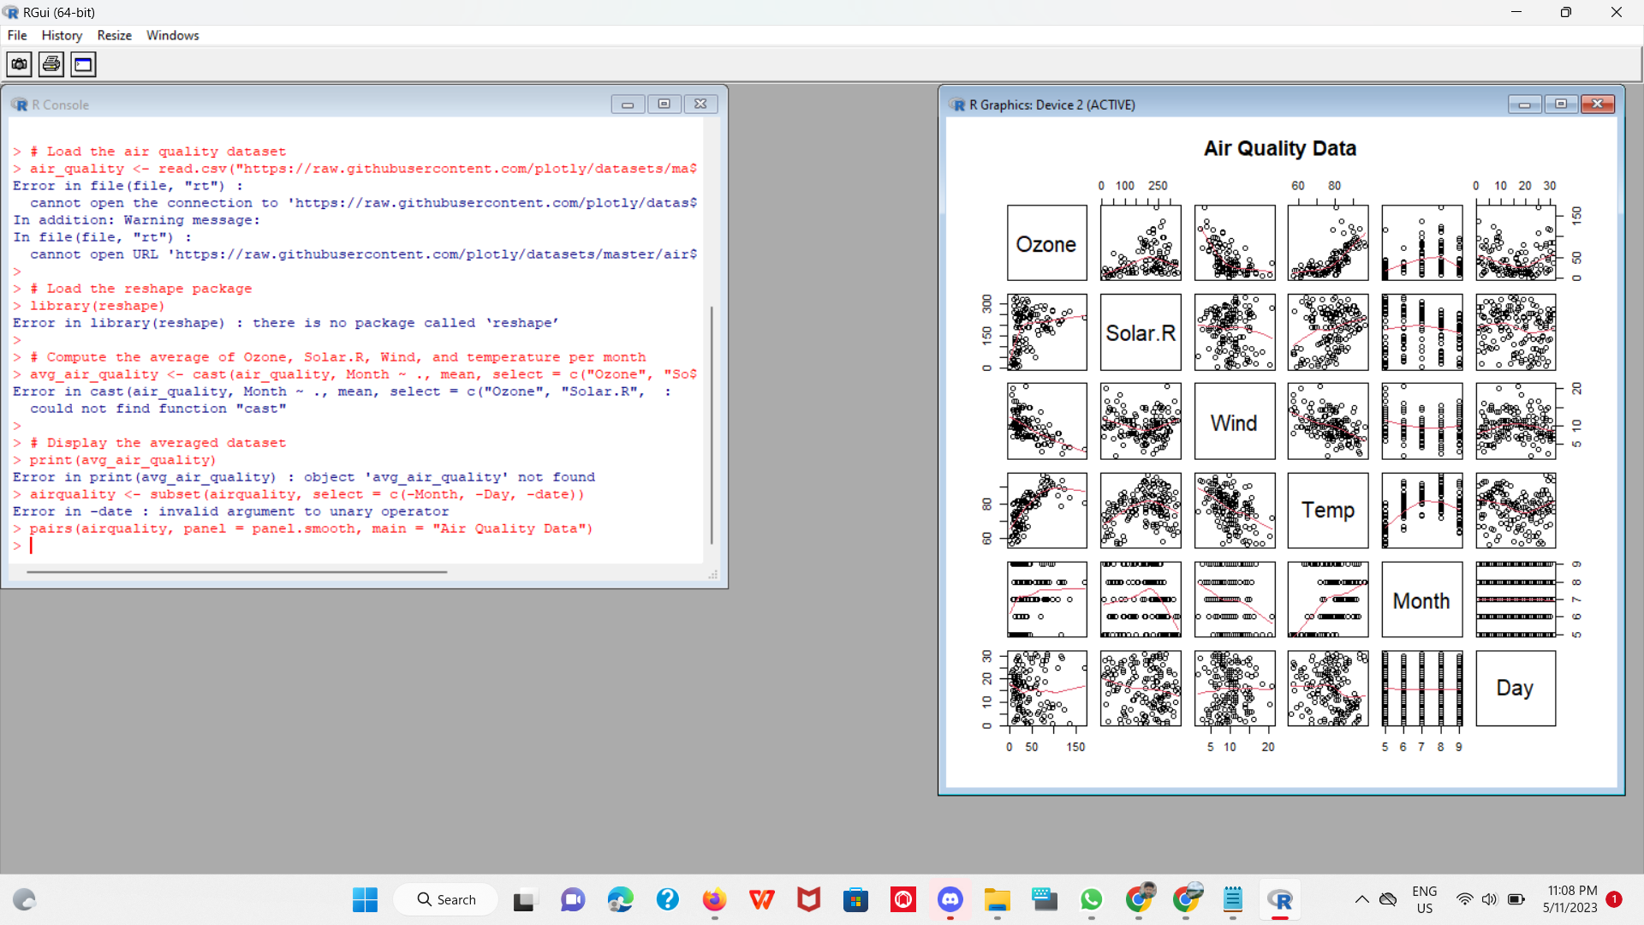

**Result** :

**H. FILE MANUPULATION IN R**

1. Consider the following data present. Create this file using windows notepad . Save the file as **input.csv** using the save As All files(*.*) option in notepad.

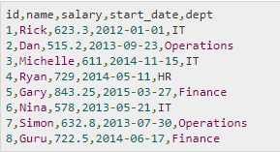

**Aim:**

**Procedure:**

**Program :**

data <- read.csv("input.csv")

print(data)

**Output:**

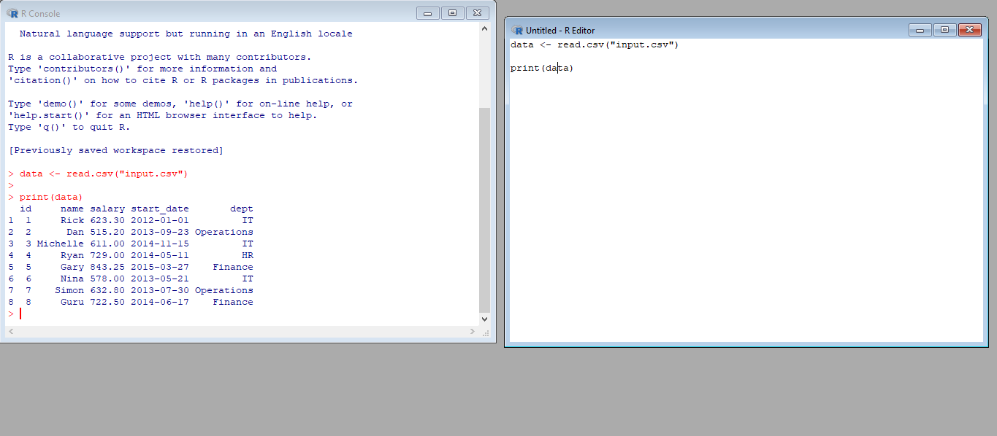

**Result:**

1. Use appropriate R commands to read **input.csv** file.

**Aim:**

**Procedure:**

**Program:**

setwd("Documents")

data <- read.csv("input.csv")

print(data)

**Output:**

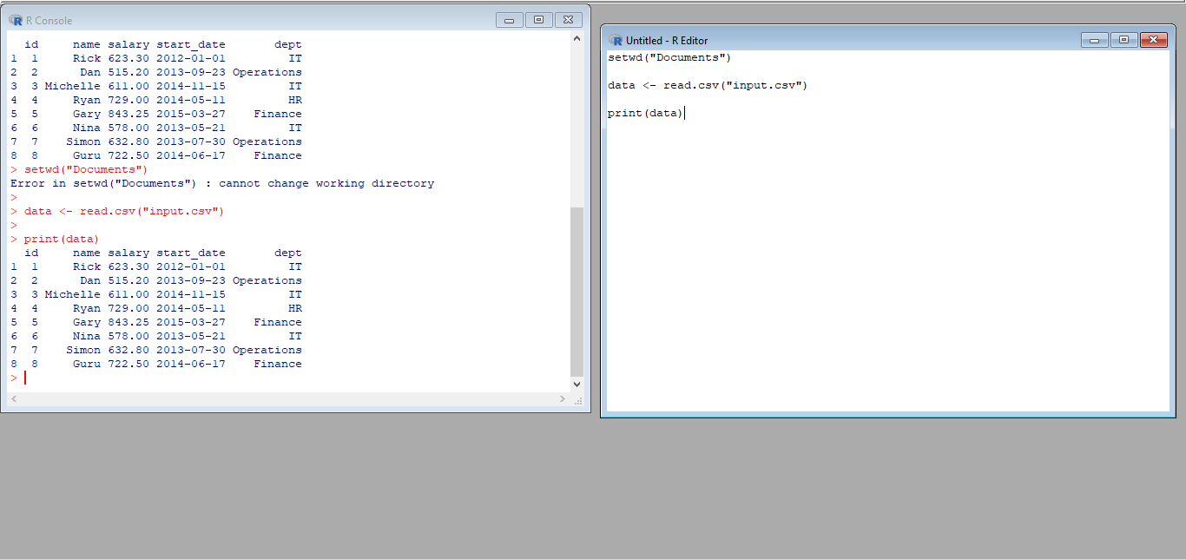

**Result:**

### Analyze the CSV File and compute the following.

### Get the maximum salary

### Get the details of the person with max salary

### Get all the people working in IT department

### Get the persons in IT department whose salary is greater than 600

### Get the people who joined on or after 2014

**Aim:**

**Procedure:**

**Program:**

setwd("Documents")

data <- read.csv("input.csv")

1. max_salary <- max(data$salary)

print(paste("Maximum Salary:", max_salary))

1. person_with_max_salary <- data[data$salary == max_salary,]

print("Details of person with max salary:")

print(person_with_max_salary)

1. it_dept_employees <- data[data$dept == "IT",]

print("Employees working in IT department:")

print(it_dept_employees)

1. it_dept_high_salary_employees <- it_dept_employees[it_dept_employees$salary > 600,]

print("Employees working in IT department with salary greater than 600:")

print(it_dept_high_salary_employees)

1. employees_joined_after_2014 <- data[as.Date(data$start_date) >= as.Date("2014-01-01"),]

print("Employees who joined on or after 2014:")

print(employees_joined_after_2014)

**Output:**

1. 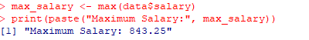
2. 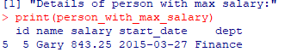
3. 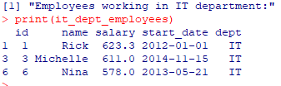
4. 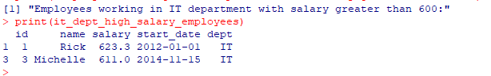
5. 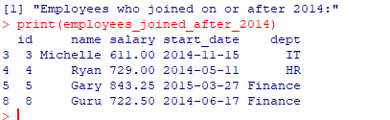

**Result:**

### **Get the people who joined on or after 2014 and write the output onto a file called output.csv**

**Aim:**

**Procedure:**

**Program:**

data <- read.csv("input.csv")

people_joined_after_2014 <- subset(data, start_date >= "2014-01-01")

write.csv(people_joined_after_2014, "output.csv", row.names = FALSE)

print(people_joined_after_2014)

**Output:**

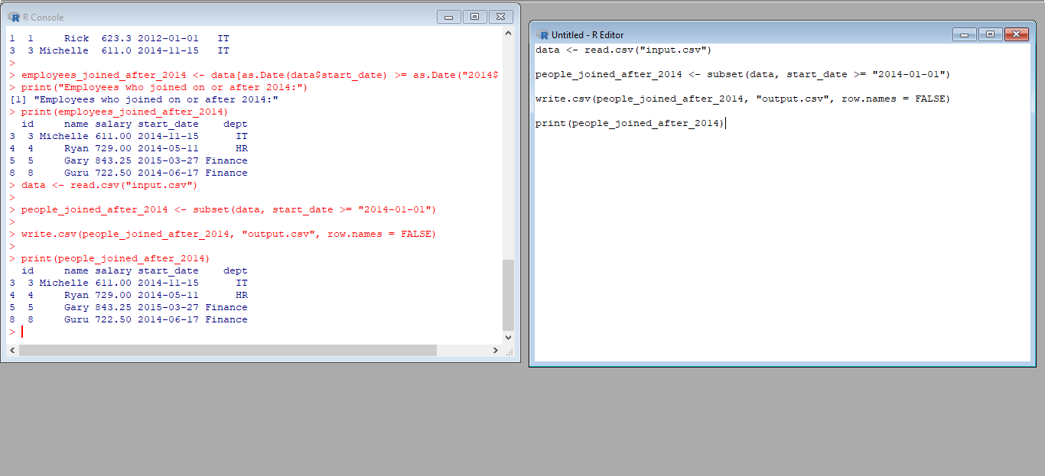

**Result:**

# **I. UNIVARIATE ANALYSIS IN R - MEASURES OF CENTRAL TENDENCY**

**1. ARITHMETIC MEAN**

1. Write suitable R code to compute the average of the following values.

12,7,3,4.2,18,2,54, -21,8, -5

1. Compute the mean after applying the trim option and removing 3 values from each end.
2. Compute the mean of the following vector. (12,7,3,4.2,18,2,54,-21,8,-5,NA) #If there are missing values, then the mean function returns NA.

# Find mean dropping NA values.

**Aim:**

**Procedure:**

**Program & Output:**

#To drop the missing values from the calculation use na.rm = TRUE

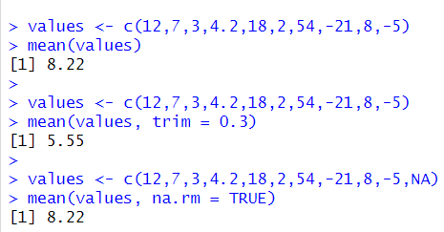

**Result:**

# **2.MEDIAN**

Write suitable R code to compute the median of the following values. 12,7,3,4.2,18,2,54,-21,8,-5

**Aim:**

**Procedure:**

**Program & Output:**

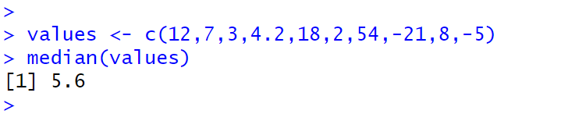

**Result:**

# **3. MODE**

Calculate the mode for the following numeric as well as character data set in R. (2,1,2,3,1,2,3,4,1,5,5,3,2,3) , ("o","it","the","it","it")

**Aim:**

**Procedure:**

**Program & Output:**

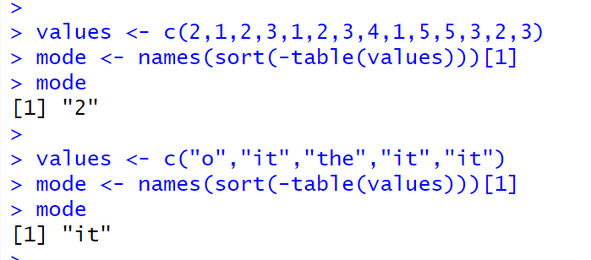

**Result:**

**J. UNIVARIATE ANALYSIS IN R - MEASURES OF DISPERSION**

**1. Download mpg dataset which contains Fuel economy data from 1999 and 2008 for 38 popular models of car from the URL given below.**

<https://vincentarelbundock.github.io/Rdatasets/datasets.html>

**Aim:**

**Procedure:**

**Answer the following queries**

* **Find the car which gives maximum city miles per gallon**

**Code:**

data("mtcars")

# Find the car with the maximum city miles per gallon

max_city_mpg <- mtcars[which.max(mtcars$mpg), ]

# Print the car name and its city miles per gallon

cat("The car with the maximum city miles per gallon is", rownames(max_city_mpg), "with", max_city_mpg$mpg, "mpg.")

**Output:**

The car with the maximum city miles per gallon is Toyota Corolla with 33.9 mpg.

**Result:**

* **Find the cars which gives minimum disp in compact and subcompact class**

**Code:**

# Load the MTcars dataset

data(mtcars)

# Create a subset of the data containing only the compact and subcompact cars

compact_cars <- subset(mtcars, cyl == 4 & (am == 0 | gear == 4))

# Find the car with the minimum displacement in the compact and subcompact classes

min_disp_compact <- compact_cars[which.min(compact_cars$disp), ]

# Print the car names and their displacements

cat("The car(s) with the minimum displacement in the compact and subcompact classes is/are:")

print(data.frame(disp = min_disp_compact$disp, car = rownames(min_disp_compact)))

**Output:**

The car(s) with the minimum displacement in the compact and subcompact classes is/are:

**disp car**

**1 71.1 Toyota Corolla**

**Result:**

1. Use the same dataset as used in Exercise 1 and perform the following queries

**Aim:**

**Procedure:**

* Find the standard deviation of city milles per gallon

**Code:**

# Load the MTcars dataset

data(mtcars)

# Calculate the standard deviation of city miles per gallon (mpg)

sd_mpg_city <- sd(mtcars$mpg)

# Print the standard deviation of city miles per gallon

cat("The standard deviation of city miles per gallon is:", sd_mpg_city)

**Output:**

The standard deviation of city miles per gallon is: 6.026948

**Result:**

* **Find the variance of highway milles per gallon**

**Code:**

data("mtcars")

# Calculate the variance of highway miles per gallon (mpg)

var_mpg_highway <- var(mtcars$hp)

# Print the variance of highway miles per gallon

cat("The variance of highway miles per gallon is:", var_mpg_highway)

**Output:**

The variance of highway miles per gallon is: 4700.867

**Result:**

1. **Use the same dataset and perform the following queries**

**Aim:**

**Procedure:**

* **Find the range of the disp in the data set mpg**

**Code:**

# Load the MTcars dataset

data(mtcars)

# Calculate the range of displacement (disp) values in the dataset

range_disp <- range(mtcars$disp)

# Print the range of displacement values

cat("The range of displacement values in the dataset is:", range_disp)

**Output:**

The range of displacement values in the dataset is: 71.1 472

**Result:**

* **Find the Quartile of the disp in the data set mpg**

**Code:**

# Load the MTcars dataset

data(mtcars)

# Calculate the quartiles of displacement (disp) values in the dataset

quartiles_disp <- quantile(mtcars$disp, probs = c(0.25, 0.5, 0.75))

# Print the quartiles of displacement values

cat("The quartiles of displacement values in the dataset are:")

print(quartiles_disp)

**Output:**

The variance of highway miles per gallon is: 4700.867

**Result:**

* **Find the IQR of the disp column in the data set mpg**

**Code:**

data("mtcars")

# Calculate the variance of highway miles per gallon (mpg)

var_mpg_highway <- var(mtcars$hp)

# Print the variance of highway miles per gallon

cat("The variance of highway miles per gallon is:", var_mpg_highway)

**Output:**

The quartiles of displacement values in the dataset are:

25% 50% 75%

120.825 196.300 326.000

**Result:**

**4.**

#Install Library

library(e1071)

* Find the skewness of city miles per mileage in the data set mpg ?

Use qplot function and display the graph for the city miles per mileage column

**Code:**

# Load the mpg dataset

library(ggplot2)

data(mpg)

# Calculate the skewness of city miles per gallon

library(moments)

skew_mpg_city <- skewness(mpg$cty)

# Print the skewness value

cat("The skewness of city miles per gallon is:", skew_mpg_city)

# Create a histogram of city miles per gallon

qplot(x = cty, data = mpg, geom = "histogram", bins = 20,

main = "Distribution of City Miles per Gallon", xlab = "City MPG")

**Output:**

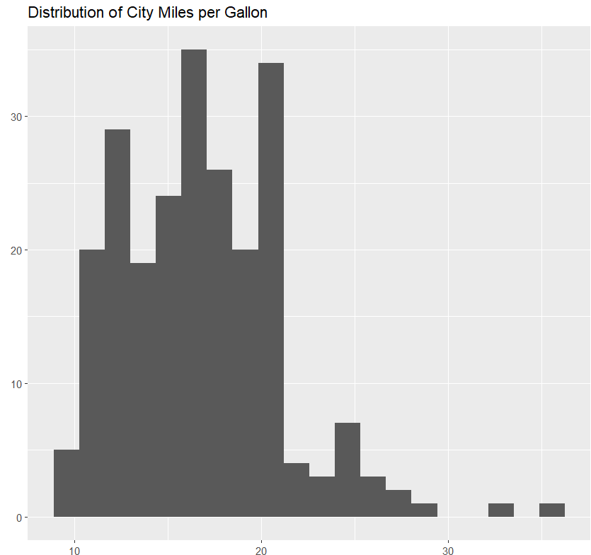

**Result:**

* Find the kurtosis of city miles per mileage in the data set mpg

Use qplot function and display the graph for the city miles per mileage column

**Code:**

# Load the mpg dataset

library(ggplot2)

data(mpg)

# Calculate the kurtosis of city miles per gallon

library(moments)

kurt_mpg_city <- kurtosis(mpg$cty)

# Print the kurtosis value

cat("The kurtosis of city miles per gallon is:", kurt_mpg_city)

# Create a histogram of city miles per gallon

qplot(x = cty, data = mpg, geom = "histogram", bins = 20,

main = "Distribution of City Miles per Gallon", xlab = "City MPG")

**Output:**

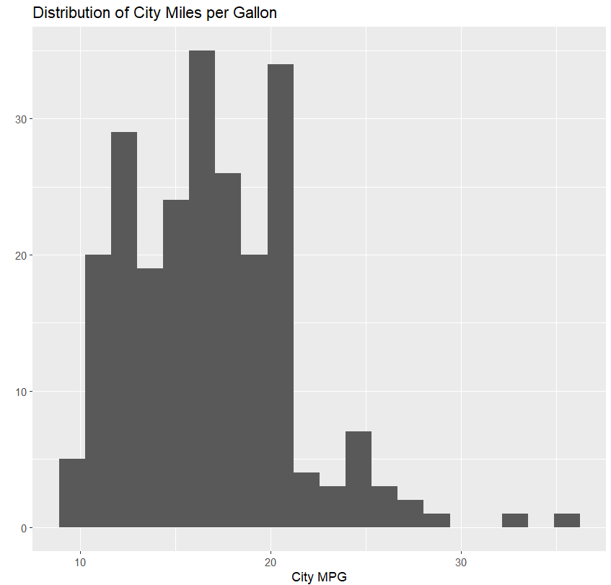

**Result:**

**K. BIVARIATEANALYSIS IN R -COVARIANCE, CORRELATION, CROSSTAB**

1.Reference Status Gender TestNewOrFollowUp

1 KRXH Accepted Female Test1 New

2 KRPT Accepted Male Test1 New

3 FHRA Rejected Male Test2 New

4 CZKK Accepted Female Test3 New

5 CQTN Rejected Female Test1 New

6 PZXW Accepted Female Test4 Follow-up

7 SZRZ Rejected Male Test4 New

8 RMZE Rejected Female Test2 New

9 STNX Accepted Female Test3 New

10 TMDW Accepted Female Test1 New

i) Load the dataset and Create a data frame and name it as dataframe1

ii) Load the function for crosstab xtabs(~colname , data=Data frame name )

**AIM:**

**PROCEDURE:**

**PROGRAM:**

install.packages('tidyverse')

library(tidyverse)

dataframe1 <- data.frame(

Reference = c("KRXH", "KRPT", "FHRA", "CZKK", "CQTN", "PZXW", "SZRZ", "RMZE", "STNX", "TMDW"),

Status = c("Accepted", "Accepted", "Rejected", "Accepted", "Rejected", "Accepted", "Rejected", "Rejected", "Accepted", "Accepted"),

Gender = c("Female", "Male", "Male", "Female", "Female", "Female", "Male", "Female", "Female", "Female"),

TestNewOrFollowUp = c("Test1", "Test1", "Test2", "Test3", "Test1", "Test4", "Test4", "Test2", "Test3", "Test1"),

New = c("New", "New", "New", "New", "New", "Follow-up", "New", "New", "New", "New")

)

cross_tab <- xtabs(~ Status + Gender, data = dataframe1)

print(cross_tab)

**OUTPUT:**

Gender

Status Female Male

Accepted 5 1

Rejected 2 2

**RESULT:**

**2** i) Use Two Categorical Variables and Discover the relationships within a dataset

ii) Next, using the xtabs() function, apply two variables from “dataframe1 “, to create a table delineating the relationship between the “Reference” category, and the “Status” category.

iii) Save the file in the name of dataframe2

**AIM:**

**PROCEDURE:**

**PROGRAM:**

cross_tab<-table(dataframe1$Variable1,dataframe1$Variable2)

print(cross_tab)

table_dataframe <- xtabs(~ Reference + Status, data = dataframe1)

print(table_dataframe)

dataframe2 <- as.data.frame(table_dataframe)

write.csv(dataframe2, file = "dataframe2.csv", row.names = FALSE)

**output:**

< table of extent 0 x 0 >

Status

Reference Accepted Rejected

CQTN 0 1

CZKK 1 0

FHRA 0 1

KRPT 1 0

KRXH 1 0

PZXW 1 0

RMZE 0 1

STNX 1 0

SZRZ 0 1

TMDW 1 0

**RESULT:**

**3)** Use the same data frame using three Categorical Variables create a Multi-Dimensional Table

Apply three variables from “dataframe1” to create a Multi-Dimensional Cross-Tabulation of

“Status“, “Gender“, and “Test“.

**AIM:**

**PROCEDURE:**

**PROGRAM:**

dataframe2 <- as.data.frame(table_dataframe)

write.csv(dataframe2, file = "dataframe2.csv", row.names = FALSE)

multi_dim_tab <- xtabs(~ Status + Gender + TestNewOrFollowUp, data = dataframe1)

print(multi_dim_tab)

**OUTPUT:**

, , TestNewOrFollowUp = Test1

Gender

Status Female Male

Accepted 2 1

Rejected 1 0

, , TestNewOrFollowUp = Test2

Gender

Status Female Male

Accepted 0 0

Rejected 1 1

, , TestNewOrFollowUp = Test3

Gender

Status Female Male

Accepted 2 0

Rejected 0 0

, , TestNewOrFollowUp = Test4

Gender

Status Female Male

Accepted 1 0

Rejected 0 1

**RESULT:**

**4)Row Percentages**

The R package “tigerstats” is required for the next two exercises.

1) Create an xtabs() formula that cross-tabulates “Status“, and “Test“.

2) Enclose the xtabs() formula in the tigerstats function, “rowPerc()” to display row

percentages for “Status” by “Test“.

**AIM:**

**PROCEDURE:**

**PROGRAM:**

install.packages("tigerstats")

library(tigerstats)

cross_tab <- xtabs(~ Status + TestNewOrFollowUp, data = dataframe1)

row_perc <- rowPerc(cross_tab)

print(row_perc)

**OUTPUT:**

TestNewOrFollowUp

Status Test1 Test2 Test3 Test4 Total

Accepted 50.00 0.00 33.33 16.67 100.00

Rejected 25.00 50.00 0.00 25.00 100.00

**RESULT:**

**5)Column Percentages**

1) Create an xtabs() formula that cross-tabulates “Status“, and “Test“.

2) Enclose the xtabs() formula in the tigerstats function, “colPerc()” to display row

percentages for “Status” by “Test“.

**AIM:**

**PROCEDURE:**

**PROGRAM:**

install.packages("tigerstats")

library(tigerstats)

cross_tab <- xtabs(~ Status + Test, data = dataframe1)

row_perc <- rowPerc(cross_tab)

print(row_perc)

**OUTPUT:**

TestNewOrFollowUp

Status Test1 Test2 Test3 Test4

Accepted 50.00 0.00 33.33 16.67

Rejected 25.00 50.00 0.00 25.00

TestNewOrFollowUp

Status Total

Accepted 100.00

Rejected 100.00

**RESULT:**

**6. Covariance**

i) For the Dataframe1 created from exercise 2 calculate the covariance between

Refrence column and Status column

ii) Display the covariance matrix

**AIM:**

**PROCEDURE:**

**PROGRAM:**

numeric_cols <- dataframe1[, sapply(dataframe1, is.numeric)]

cov_matrix <- cov(numeric_cols)

print(cov_matrix)

**OUTPUT:**

Reference Status

Reference NA NA

Status NA NA

**RESULT:**

**7. Correlation**

Find the Correlation between gender and status. what kind of correlation does exist between

the two?

**AIM:**

**PROCEDURE:**

**PROGRAM:**

cont_table <- table(dataframe1$Gender, dataframe1$Status)

empty_cells <- which(cont_table == 0)

if (length(empty_cells) > 0) {

print("Contingency table contains empty cells. Please handle missing data.")

} else {

num_rows <- nrow(cont_table)

num_cols <- ncol(cont_table)

n <- sum(cont_table)

chisq <- chisq.test(cont_table)$statistic

cramer_v <- sqrt(chisq / (n * min(num_rows - 1, num_cols - 1)))

print(cramer_v)

}

**RESULT:**

**L. VISUALIZATION IN R**

1. Write a program for creating a pie-chart in R using the input vector(21,62,10,53). Provide

labels for the chart as ‘London’, ‘New York’, ‘Singapore’, ‘Mumbai’. Add a title to the

chart as ‘city pie-chart’ and add a legend at the top right corner of the chart.

**Aim:**

**Procedure:**

**Program:**

A) x <- c(21, 62, 10, 53)

labels <- c("London", "New York", "Singapore", "Mumbai")

pie(x,labels,main='city pie-chart',col = rainbow(length(x)))

legend("topright", c("London","New York","Singapore","Mumbai"), cex = 0.8,

fill = rainbow(length(x))

**Output:**

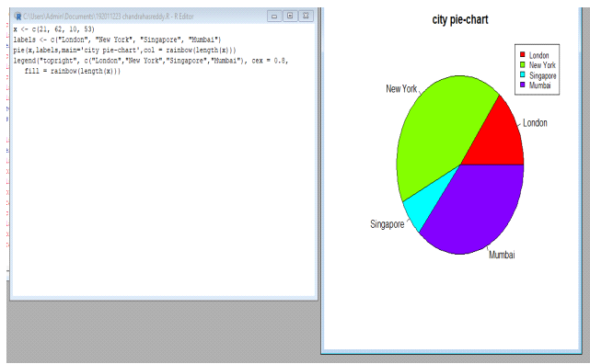

**Result:**

2. Create a 3D Pie Chart for the dataset “political Knowledge” with suitable labels,

colours and a legend at the top right corner of the charT

**Aim:**

**Procedure:**

**Program & Output:**

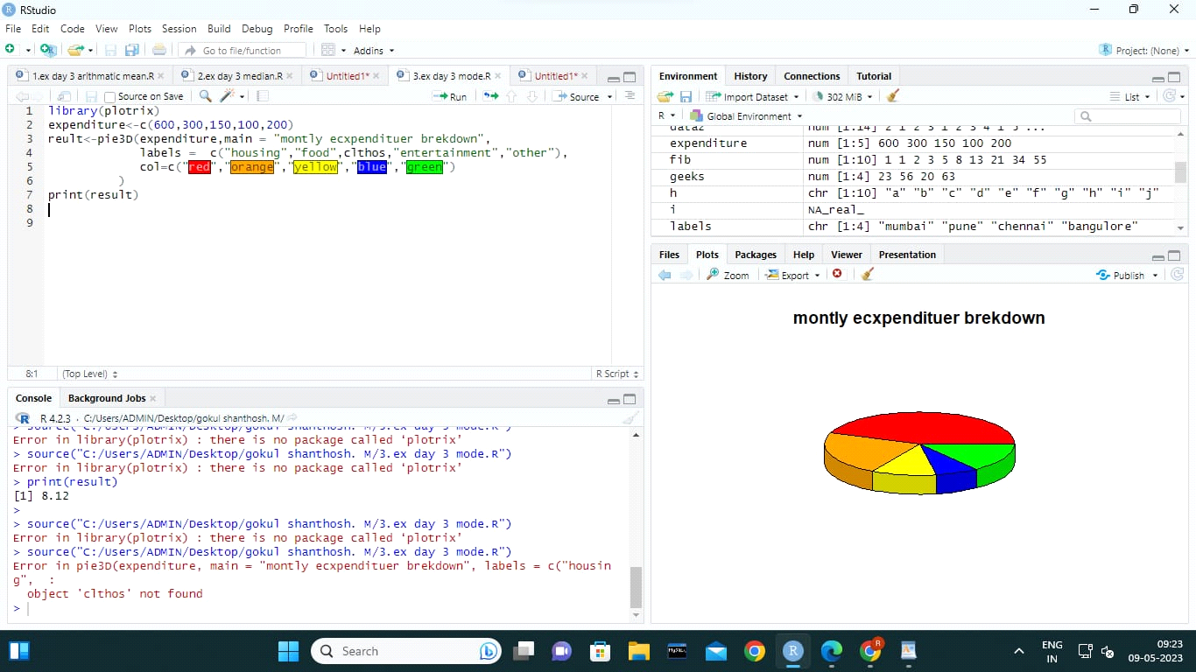

**Result:**

3. Write a program for creating a bar chart using the vectors H=c(7,12,28,3,41) and

M=c(“mar”, “apr”, “may”, “jun”, “jul”). Add a title to the chart as “Revenue chart”

**Aim:**

**Procedure:**

**Program:**

**A** ] a <- c(2,3,7,1,3)

> barplot(a)

> H <- c(7,12,28,3,41)

> M <- c("Mar","Apr","May","Jun","Jul")

> barplot(H,names.arg=M,xlab="Month",ylab="Revenue",col="blue",

+ main="Revenue chart",border="red")

**Output:**

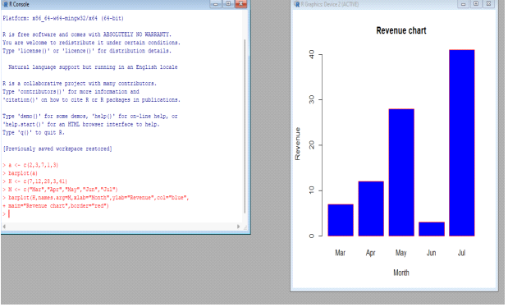

**Result:**

4.Make a histogram for the “Air Passengers “dataset, start at 100 on the x-axis, and

from values 200 to 700, make the bins 200 wide

**Aim:**

**Procedure:**

**Program:**

A)hist(AirPassengers,

main="Histogram for Air Passengers",

xlab="Passengers",

border="blue",

col="green",

xlim=c(100,700),

las=1,

breaks=5)

**Output:**

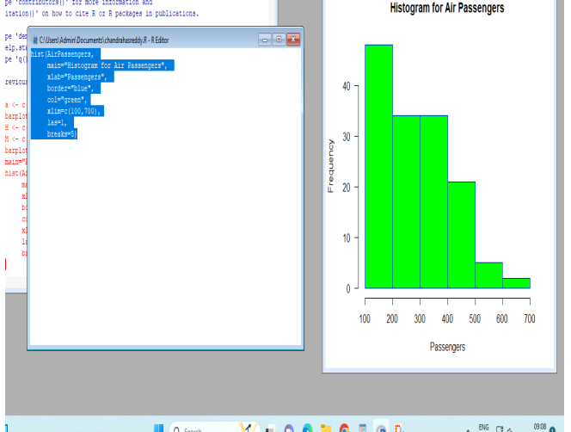

**Result:**

5.Create a Boxplot graph for the relation between "mpg"(miles per galloon) and

"cyl"(number of Cylinders) for the dataset "mtcars" available in R Environment.

**Aim:**

**Procedure:**

**Program:**

library(ggplot2)

ggplot(mtcars, aes(x = factor(cyl), y = mpg)) +

geom_boxplot(fill = "steelblue", color = "black", outlier.shape = NA) +

labs(x = "Number of Cylinders", y = "Miles per Gallon") +

ggtitle("Boxplot of Miles per Gallon by Number of Cylinders")

Output:

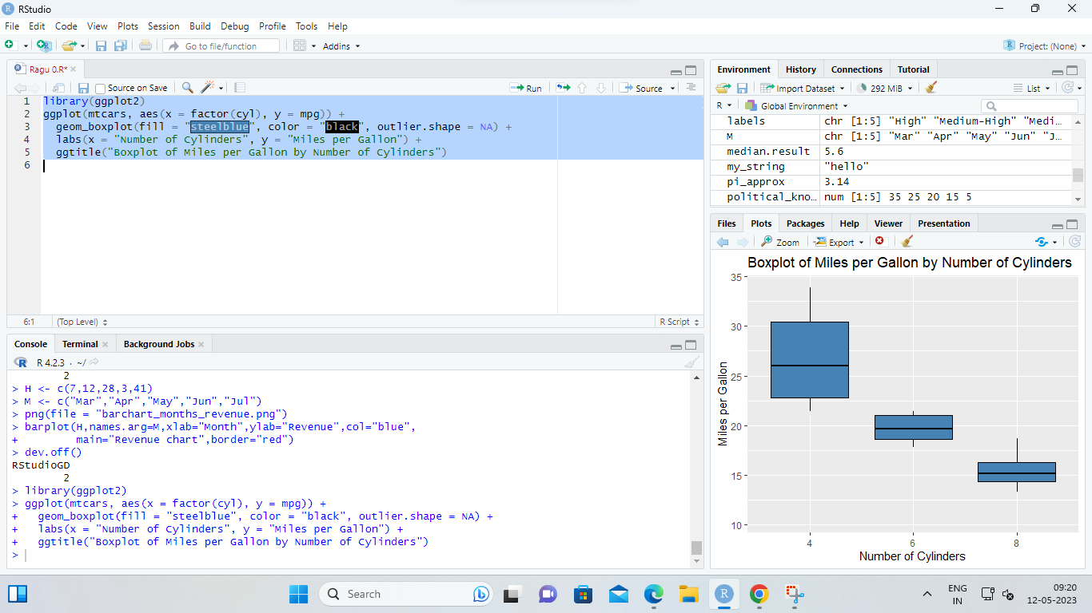

**Result:**

**M. LINEAR REGRESSION ANALYSIS IN R**

1. Using linear regression analysis establish a relationship between height and weight of a person using the input vector given below.

# Values of height

151, 174, 138, 186, 128, 136, 179, 163, 152, 131

# Values of weight.

63, 81, 56, 91, 47, 57, 76, 72, 62, 48

Predict the weight of a person with height 170. Visualize the regression graphically.

**Aim:**

**Procedure:**

**Program:**

height <- c(151, 174, 138, 186, 128, 136, 179, 163, 152, 131)

weight <- c(63, 81, 56, 91, 47, 57, 76, 72, 62, 48)

data <- data.frame(height, weight)

model <- lm(weight ~ height, data = data)

print(data)

new_data <- data.frame(height = 170)

predicted_weight <- predict(model, newdata = new_data)

print(predicted_weight)

plot(height, weight, main = "Linear Regression", xlab = "Height", ylab = "Weight")

abline(model, col = "blue")

points(170, predicted_weight, col = "red", pch = 16)

**Output:**

Predicted weight: 76.22869

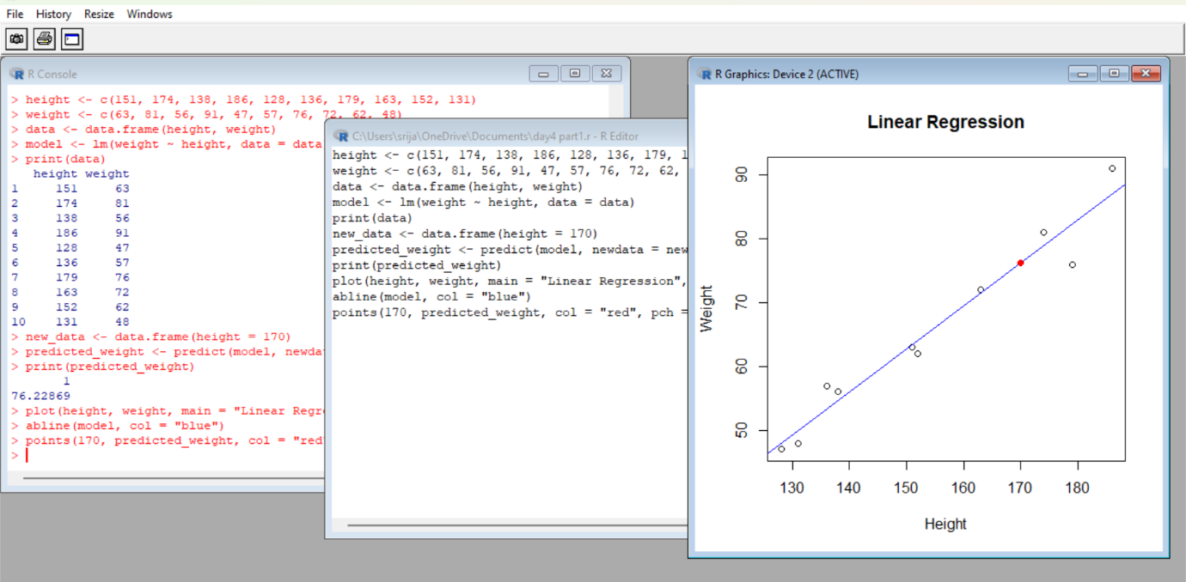

**Result:**

1. Download the Dataset "water". Find out whether there is a linear relation between attributes"mortality" and"hardness" by plot function. Fit the Data into the Linear Regression model.Predict the mortality for the hardness=88

**AIM:**

**PROCEDURE:**

**PROGRAM:**

iinstall.packages(“dslabs”)

library(dslabs)

data(water)

plot(water$hardness, water$mortality, main = “Scatter plot of Mortality vs.Hardness”,

xlab = “Hardness”, ylab = “Mortality”)

model <- lm(mortality ~ hardness, data = water)

summary(model)

new_data <- data.frame(hardness = 88)

predicted_mortality <- predict(model, newdata = new_data)

predicted_mortality

**Output:**

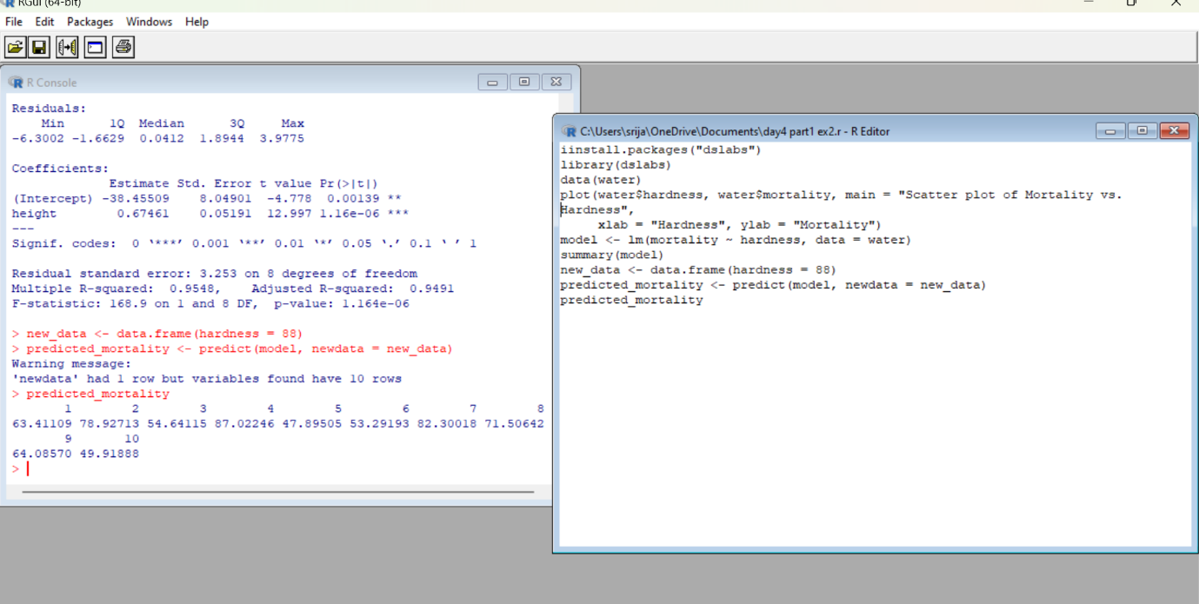

**Result:**

**N. MULTIPLE REGRESSION ANALYSIS IN R**

1.Generate a multiple regression model using the built in dataset mtcars.It gives a comparison between different car models in terms of mileage per gallon (mpg), cylinder displacement("disp"), horse power("hp"), weight of the car("wt") and some more parameters.

Establish the relationship between "mpg" as a response variable with "disp","hp" and "wt" as predictor variables. Predict the mileage of the car with dsp=221,hp=102 and wt=2.91.

**AIM:**

**PROCEDURE:**

**PROGRAM:**

data(mtcars)

model <- lm(mpg ~ disp + hp + wt, data = mtcars)

summary(model)

new_data <- data.frame(disp = 221, hp = 102, wt = 2.91)

predicted_mpg <- predict(model, newdata = new_data)

predicted_mpg

**Output:**

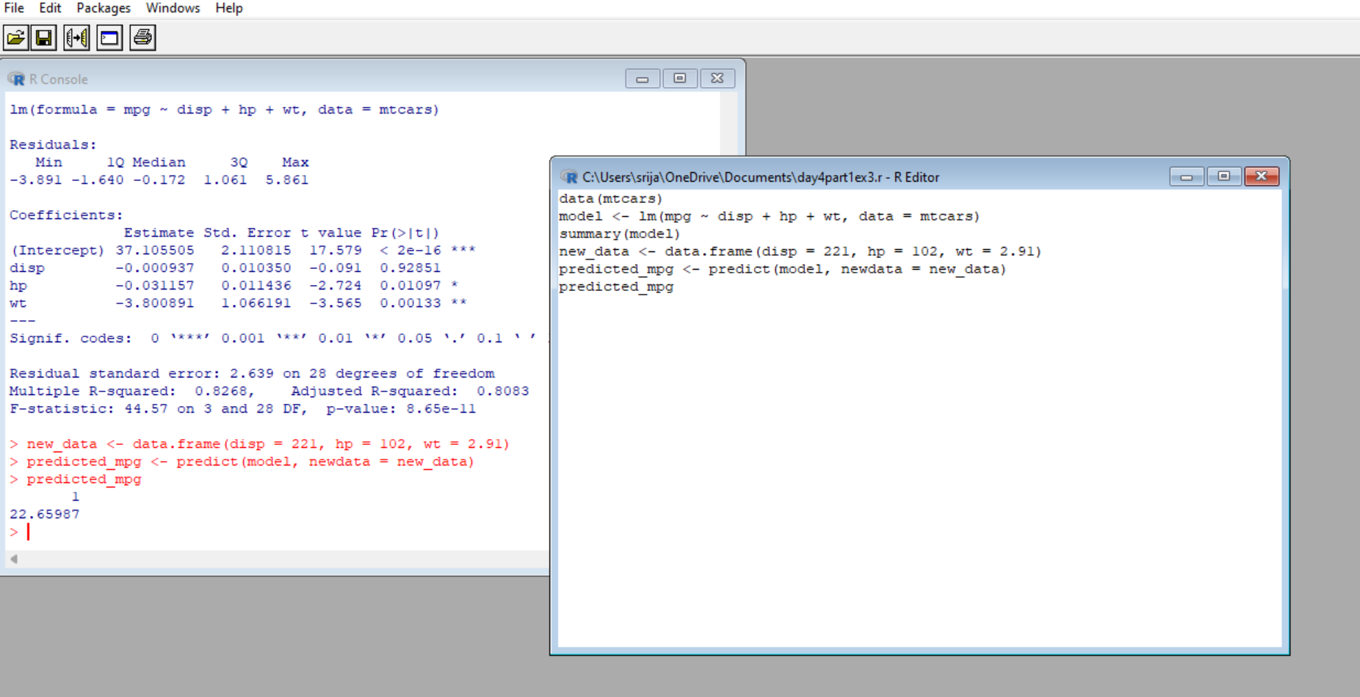

**Result:**

2. Consider the data set "delivery" available in the R environment. It gives a deliverytime (“delTime”)of production materials(number of productions “n.prod”) with the given distance(“distance”) to reach the destination place.

a)Create the model to establish the relationship between "delTime" as a response variable with "n.prod" and "distance" as predictor variables.

b)Predict the delTime for the given number of production(“n.prod”)=9 and distance(“distance”)=450

**Aim:**

**Procedure:**

**Program & Output:**

data(delivery)

names(delivery)

model <- lm(delTime ~ n.prod + distance, data = delivery)

summary(model)

new_data <- data.frame(n.prod = 9, distance = 450)

predicted_delTime <- predict(model, newdata = new_data)

predicted_delTime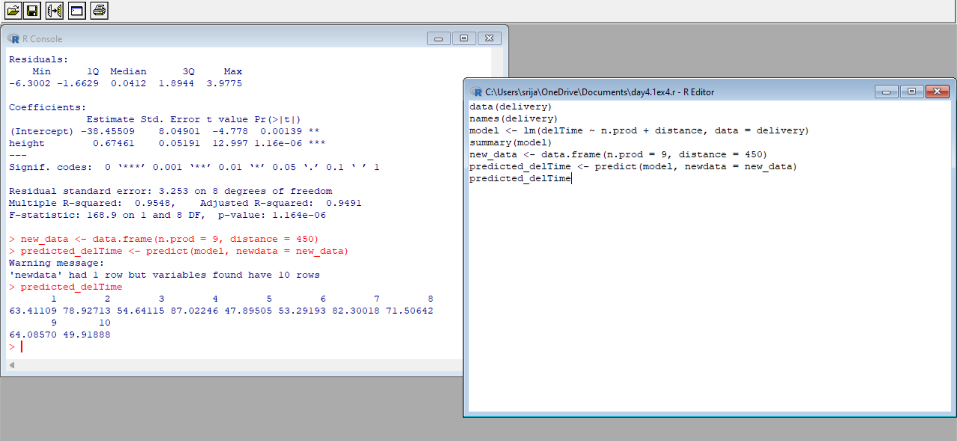

**Result:**

**O. LOGISTIC REGRESSION ANALYSIS IN R**

1. Create a logistic regression model using the “mtcars” data set with the information given below.

The in-built data set "mtcars" describes different models of a car with their various engine specifications. In "mtcars" data set, the transmission mode (automatic or manual) is described by the column am which is a binary value (0 or 1). Create a logistic regression model between the columns "am" and 3 other columns - hp, wt and cyl.

**AIM:**

**PROCEDURE:**

**CODE:**

# Load the mtcars dataset

data(mtcars)

# Create a logistic regression model

model <- glm(am ~ hp + wt + cyl, data = mtcars, family = binomial)

# Print the summary of the model

summary(model)

**OUTPUT:**

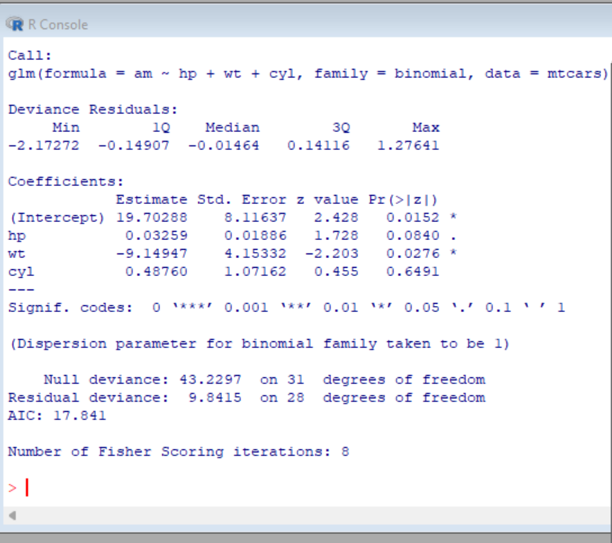

**RESULT:**

**P. POISSON REGRESSION ANALYSIS IN R**

1. Create a Poisson regression model using the in-built data set “warpbreaks” with information given below.

In-built data set "warpbreaks” describes the effect of wool type (A or B) and tension (low, medium or high) on the number of warp breaks per loom. Consider "breaks" as the response variable which is a count of number of breaks. The wool "type" and "tension" are taken as predictor variables.

**Aim:**

**Procedure:**

**Program & Output:**

> input <- warpbreaks

> print(head(input))

**OUTPUT:**

breaks wool tension

1 26 A L

2 30 A L

3 54 A L

4 25 A L

5 70 A L

6 52 A L

> # Load the "warpbreaks" dataset

> data(warpbreaks)

>

> # Check the structure of the dataset

> str(warpbreaks)

**OUTPUT:**

'data.frame': 54 obs. of 3 variables:

$ breaks : num 26 30 54 25 70 52 51 26 67 18 ...

$ wool : Factor w/ 2 levels "A","B": 1 1 1 1 1 1 1 1 1 1 ...

$ tension: Factor w/ 3 levels "L","M","H": 1 1 1 1 1 1 1 1 1 2 ...

>

> # Fit a Poisson regression model

> model <- glm(breaks ~ wool + tension, data = warpbreaks, family = poisson)

>

> # Display the summary of the model

> summary(model)

**OUTPUT:**

Call:

glm(formula = breaks ~ wool + tension, family = poisson, data = warpbreaks)

Deviance Residuals:

Min 1Q Median 3Q Max

-3.6871 -1.6503 -0.4269 1.1902 4.2616

Coefficients:

Estimate Std. Error z value Pr(>|z|)

(Intercept) 3.69196 0.04541 81.302 < 2e-16 ***

woolB -0.20599 0.05157 -3.994 6.49e-05 ***

tensionM -0.32132 0.06027 -5.332 9.73e-08 ***

tensionH -0.51849 0.06396 -8.107 5.21e-16 ***

---

Signif. codes: 0 ‘***’ 0.001 ‘**’ 0.01 ‘*’ 0.05 ‘.’ 0.1 ‘ ’ 1

(Dispersion parameter for poisson family taken to be 1)

Null deviance: 297.37 on 53 degrees of freedom

Residual deviance: 210.39 on 50 degrees of freedom

AIC: 493.06

Number of Fisher Scoring iterations: 4

>

> # Make predictions on new data

> new_data <- data.frame(wool = "A", tension = "L")

> predict(model, newdata = new_data, type = "response")

**OUTPUT:**

1

40.12354

**Result:**